## 1.查询student表中的所有记录的sname、ssex和class列。

SELECT sname,ssex,class FROM day07.student;

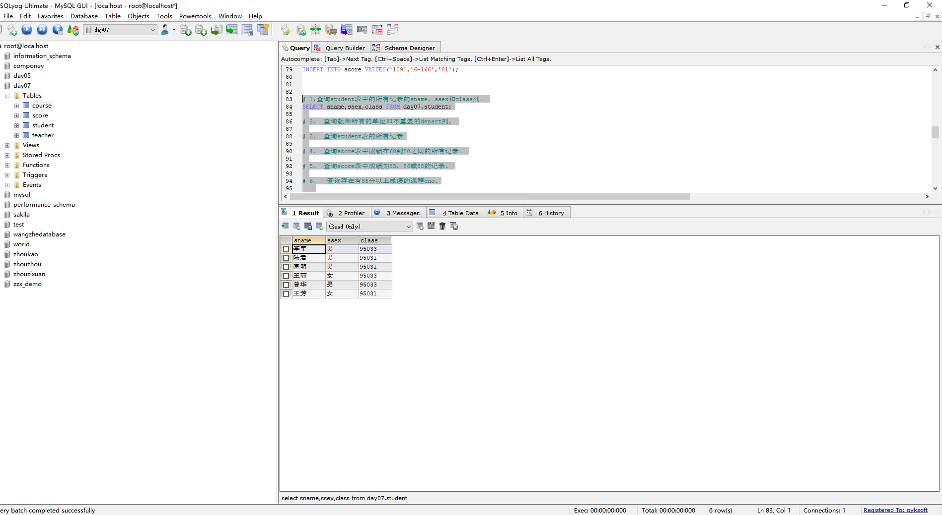

## 

## 查询教师所有的单位即不重复的depart列。

SELECT DISTINCT depart FROM teacher;

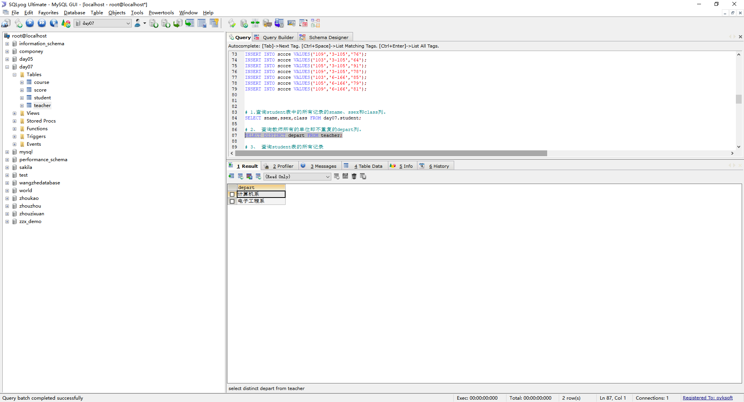

## 

## 查询student表的所有记录

SELECT * FROM student;

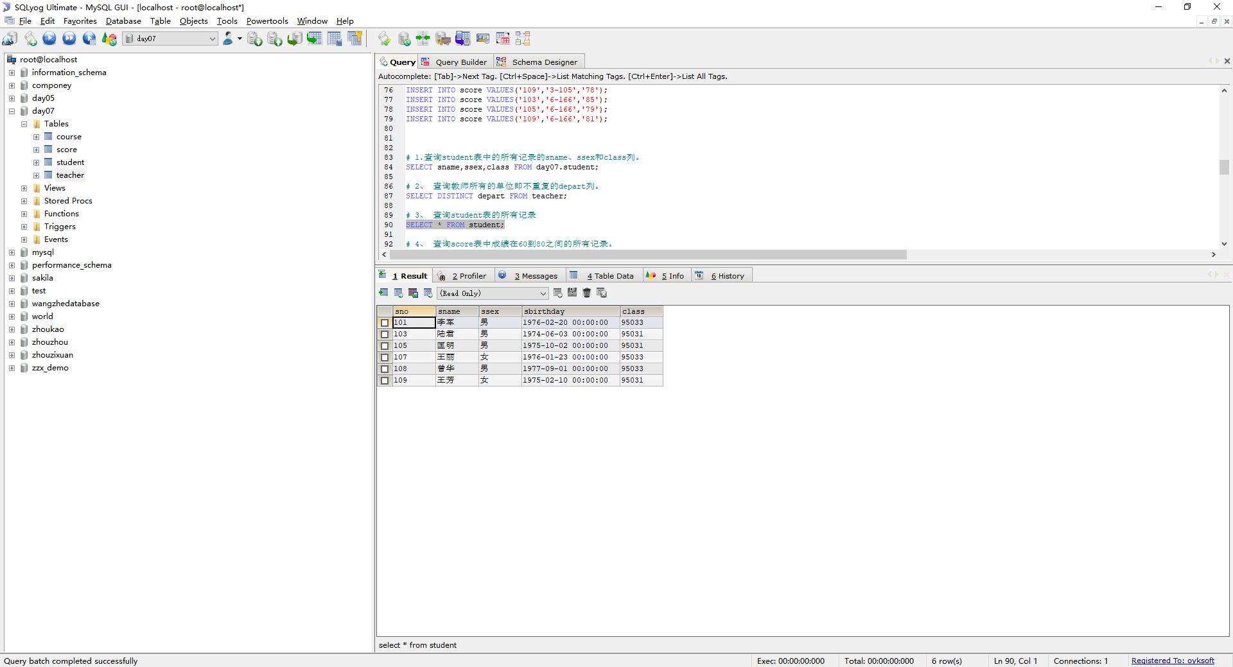4、 查询score表中成绩在60到80之间的所有记录。

SELECT * FROM day07.score WHERE degree BETWEEN 60 AND 80;

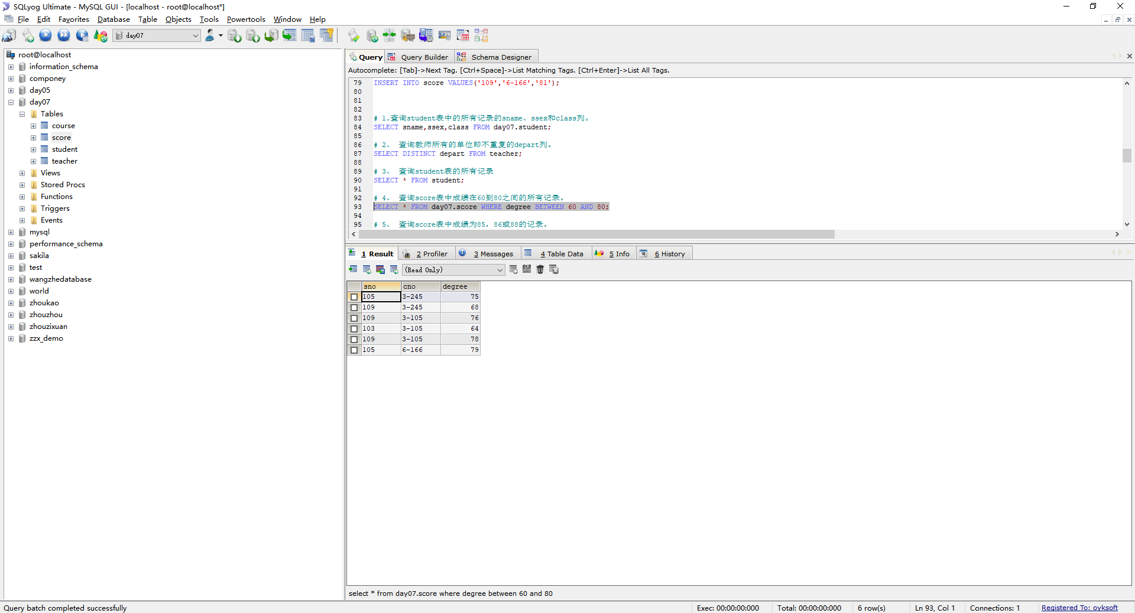

## 5、查询score表中成绩为85，86或88的记录。

SELECT * FROM score WHERE degree IN(85,86,88);

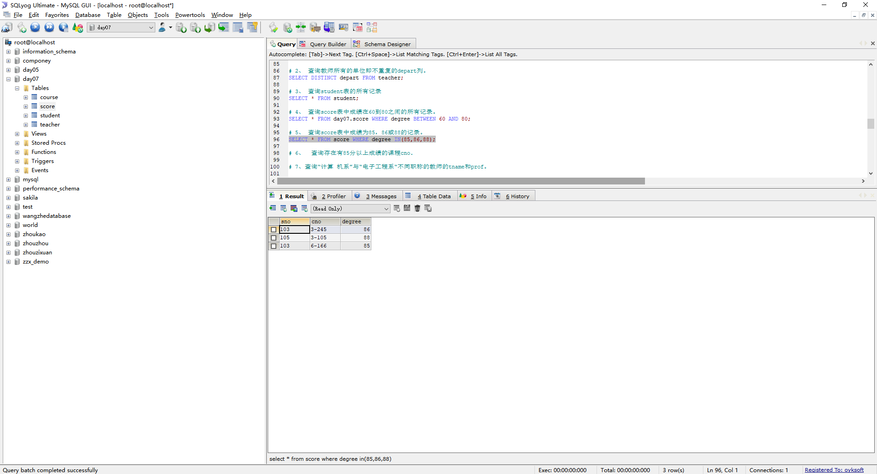

6、 查询存在有85分以上成绩的课程cno

SELECT cno FROM score WHERE degree > 85;

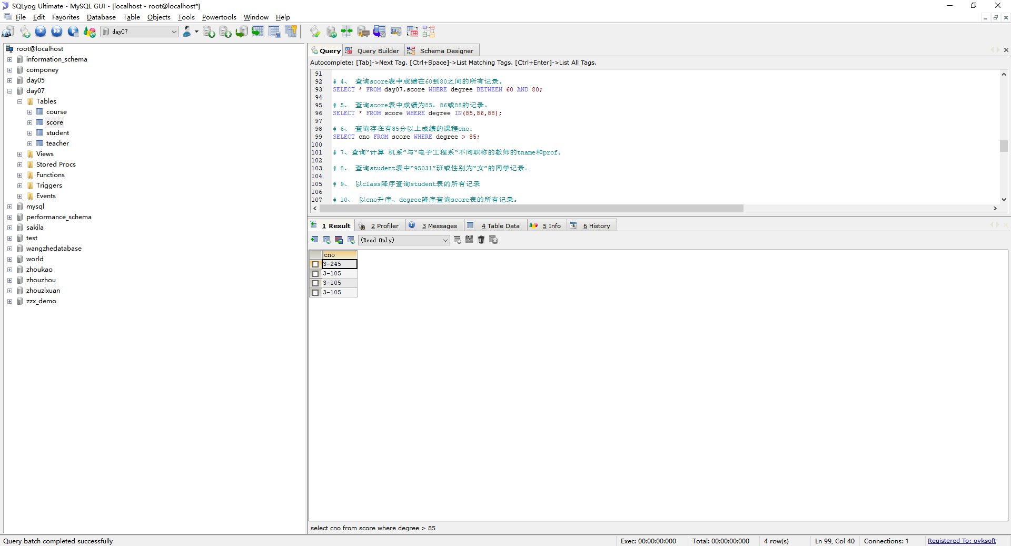

## 查询“计算 机系”与“电子工程系“不同职称的教师的tname和prof。

SELECT tname,prof FROM teacher WHERE depart IN('计算机系','电子工程系') GROUP BY prof;

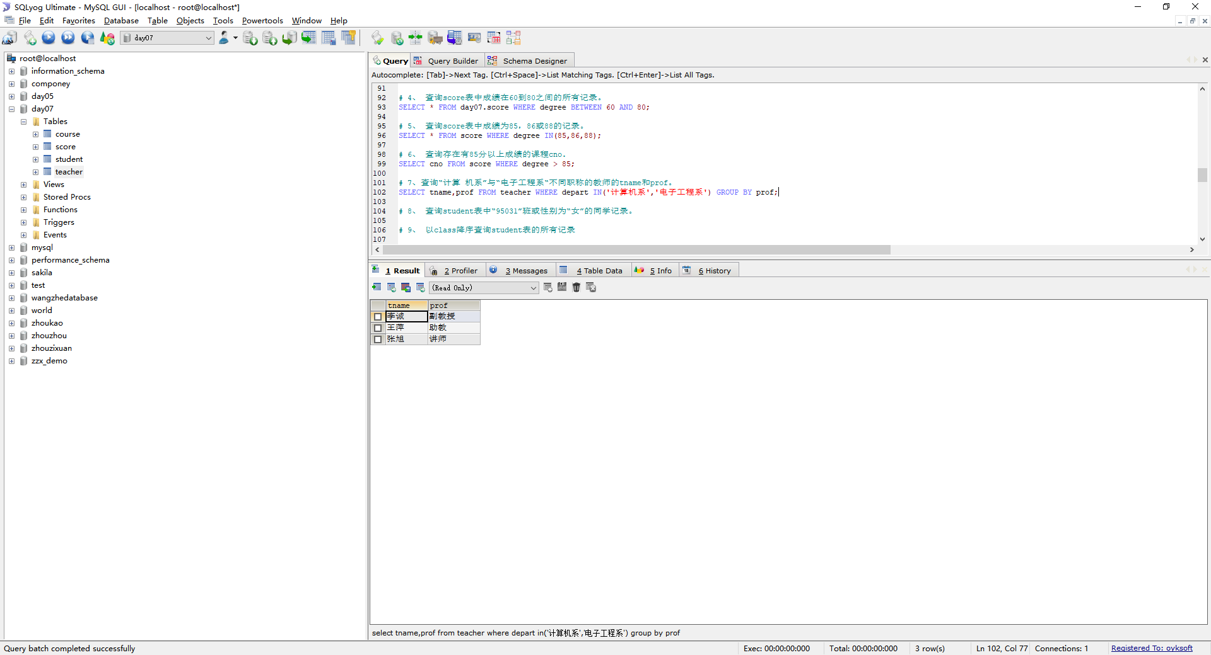

## 查询student表中“95031”班或性别为“女”的同学记录。

SELECT * FROM student WHERE class = '95031' OR ssex = '女';

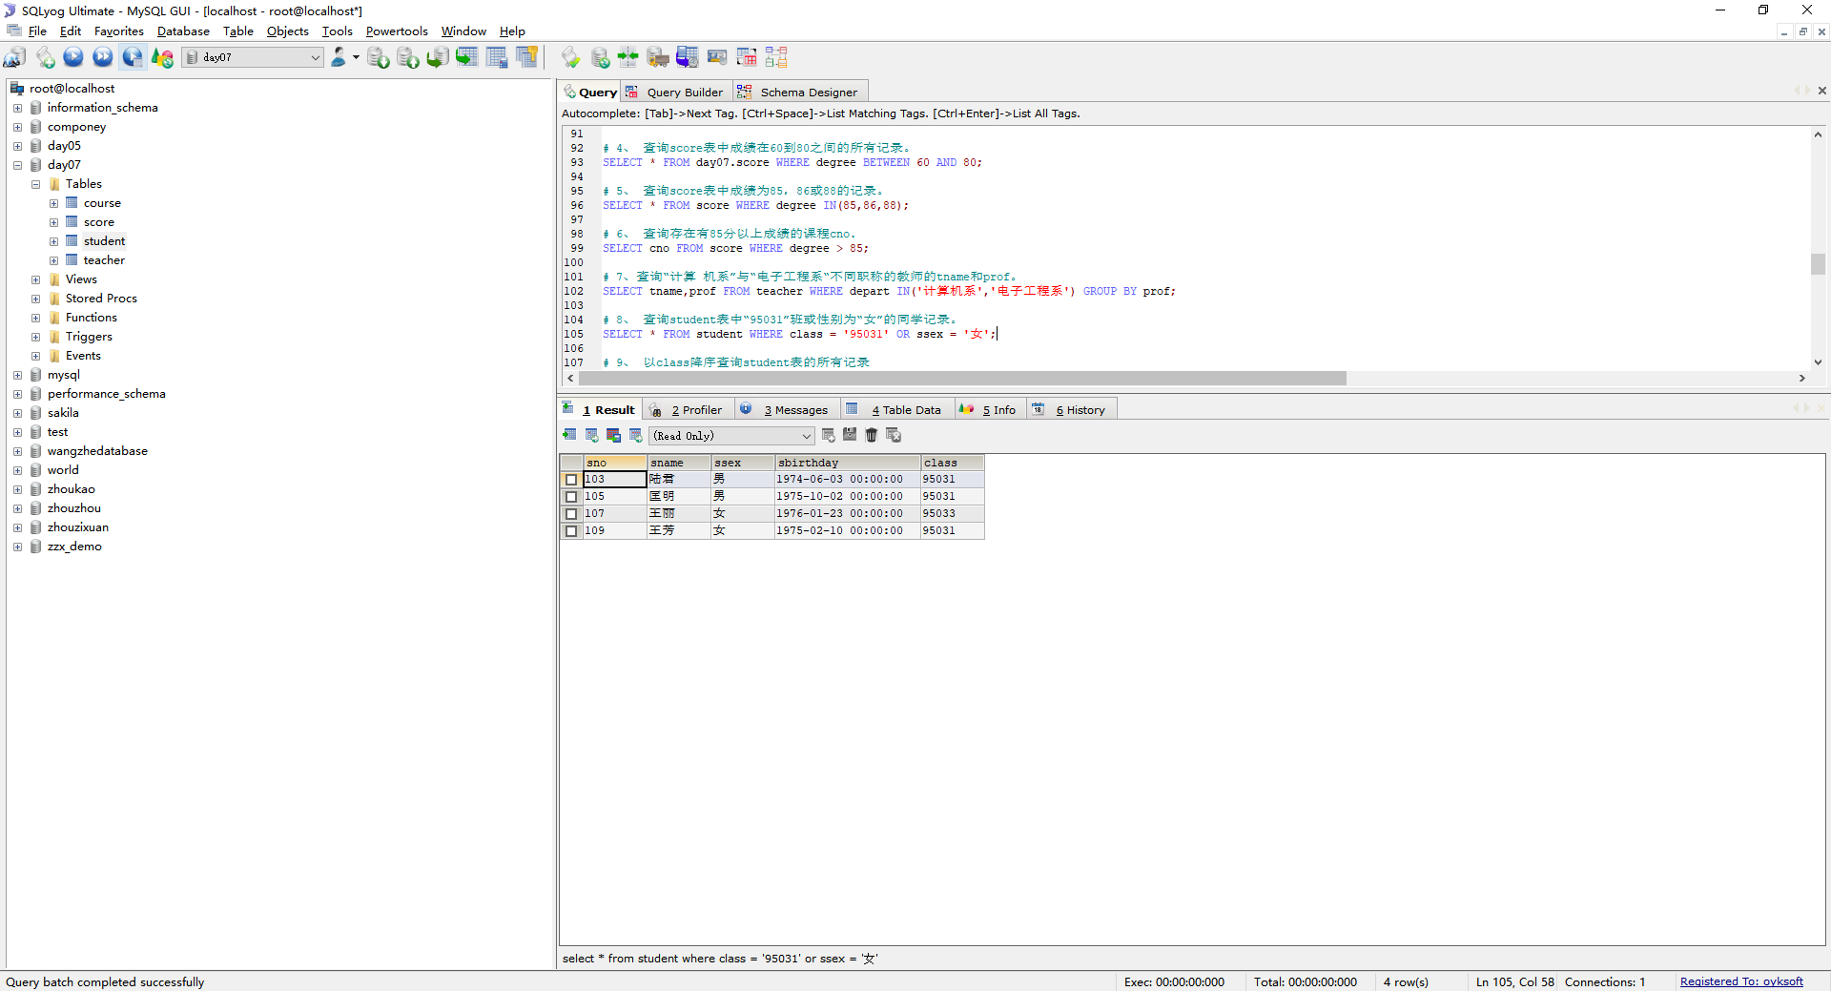

## 以class降序查询student表的所有记录

SELECT * FROM student ORDER BY class DESC;

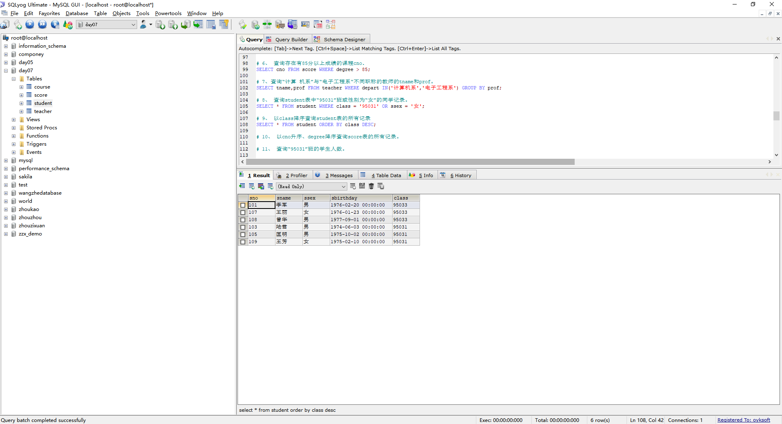

## 以cno升序、degree降序查询score表的所有记录。

SELECT * FROM score ORDER BY cno ASC,degree DESC;

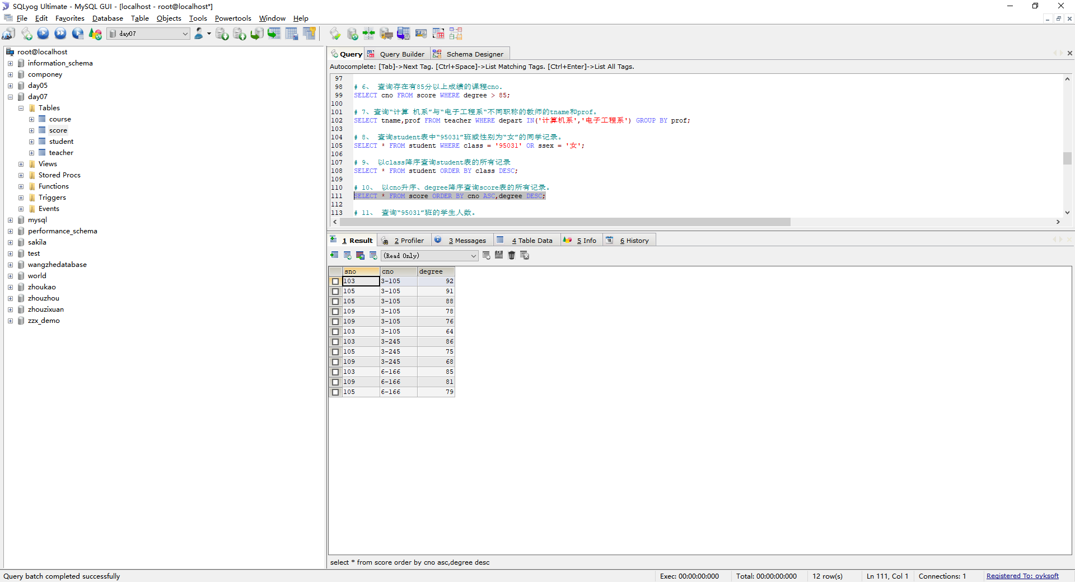

## 查询“95031”班的学生人数。

SELECT COUNT(class) FROM student WHERE class = '95031';

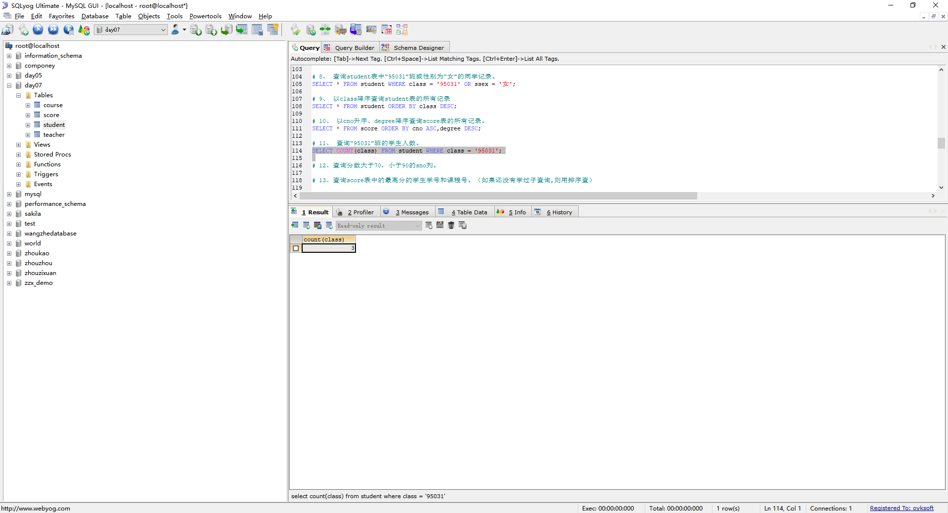

## 查询分数大于70，小于90的sno列。

SELECT sno FROM score WHERE degree >70 AND degree < 90;

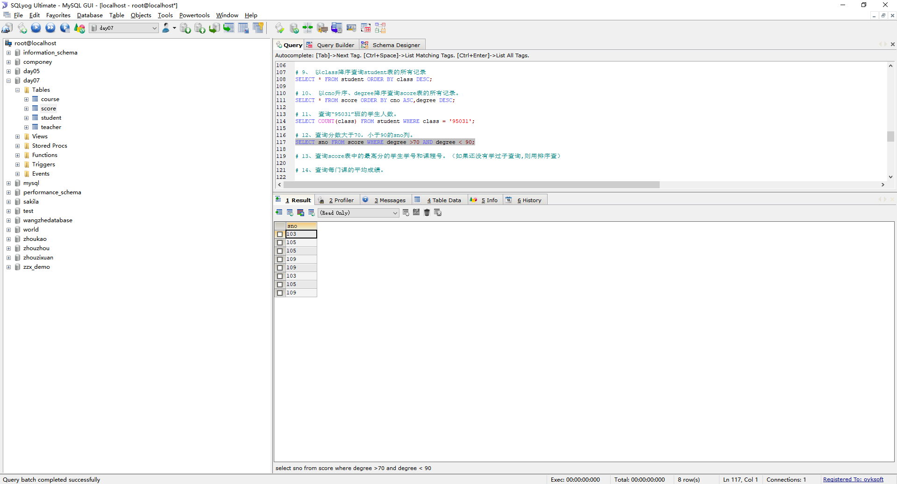

## 查询score表中的最高分的学生学号和课程号。（如果还没有学过子查询,则用排序查）

SELECT sno,cno FROM score WHERE degree = (SELECT MAX(degree) FROM score);

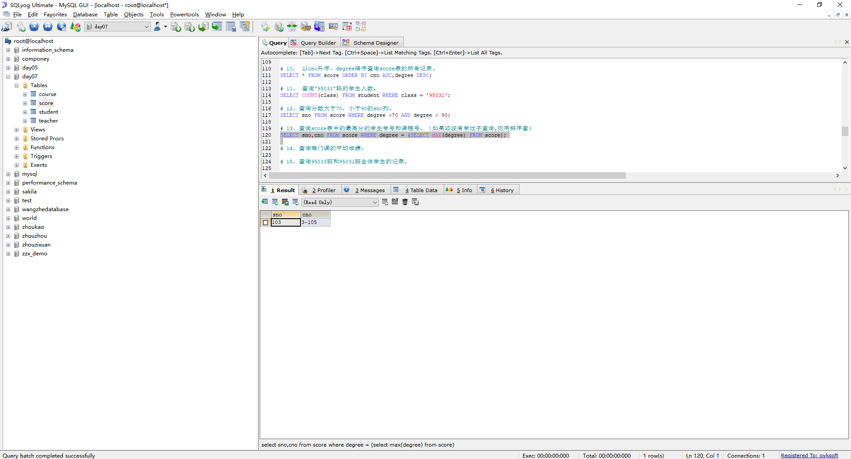

## 查询每门课的平均成绩。

SELECT cno,AVG(degree) FROM score GROUP BY cno;

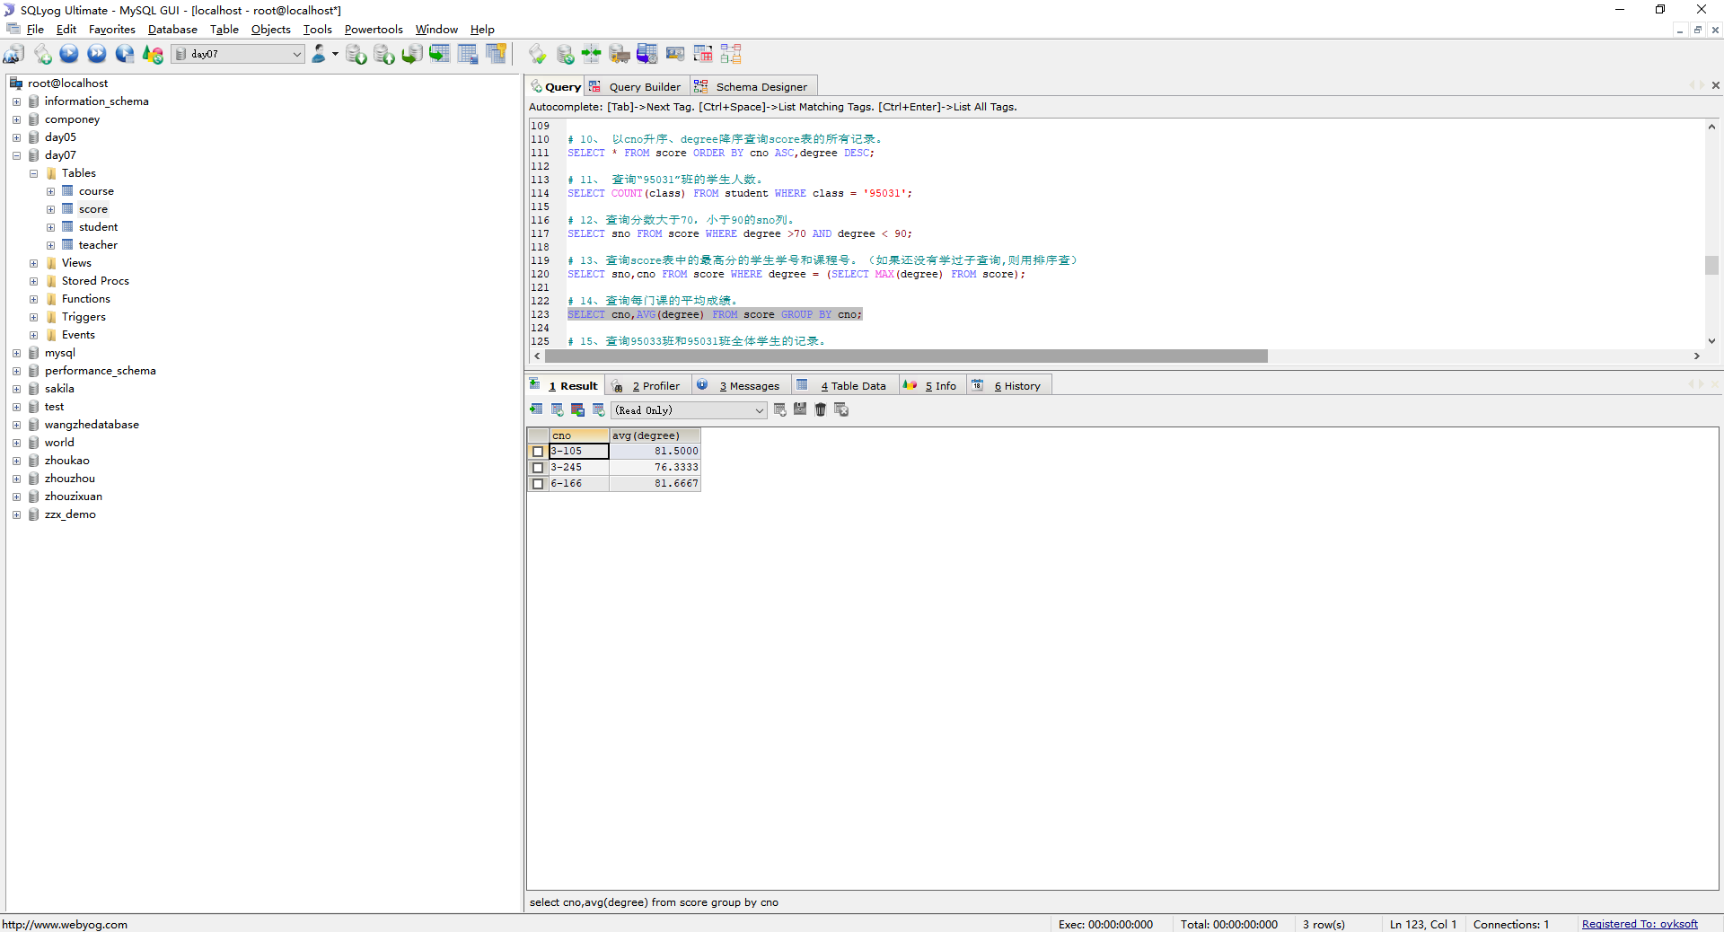

## 查询95033班和95031班全体学生的记录。

SELECT * FROM student WHERE class IN('95033','95031');

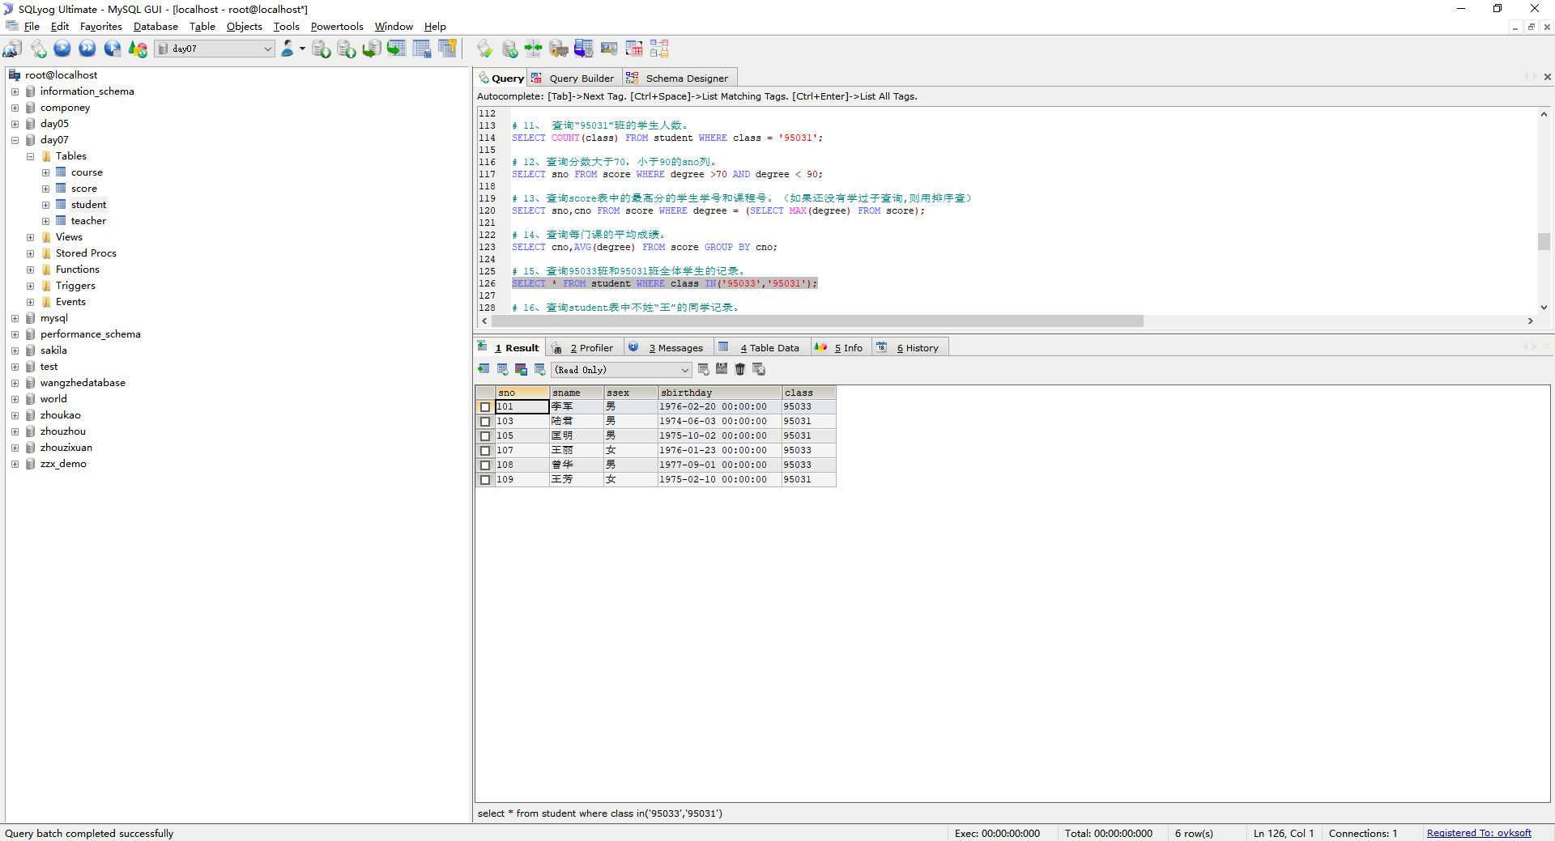

## 查询student表中不姓“王”的同学记录。

-- left() 函数方法

SELECT * FROM student WHERE LEFT(sname,1) <> '王';

-- like 模糊查询方法

SELECT * FROM student WHERE sname NOT LIKE '王%';

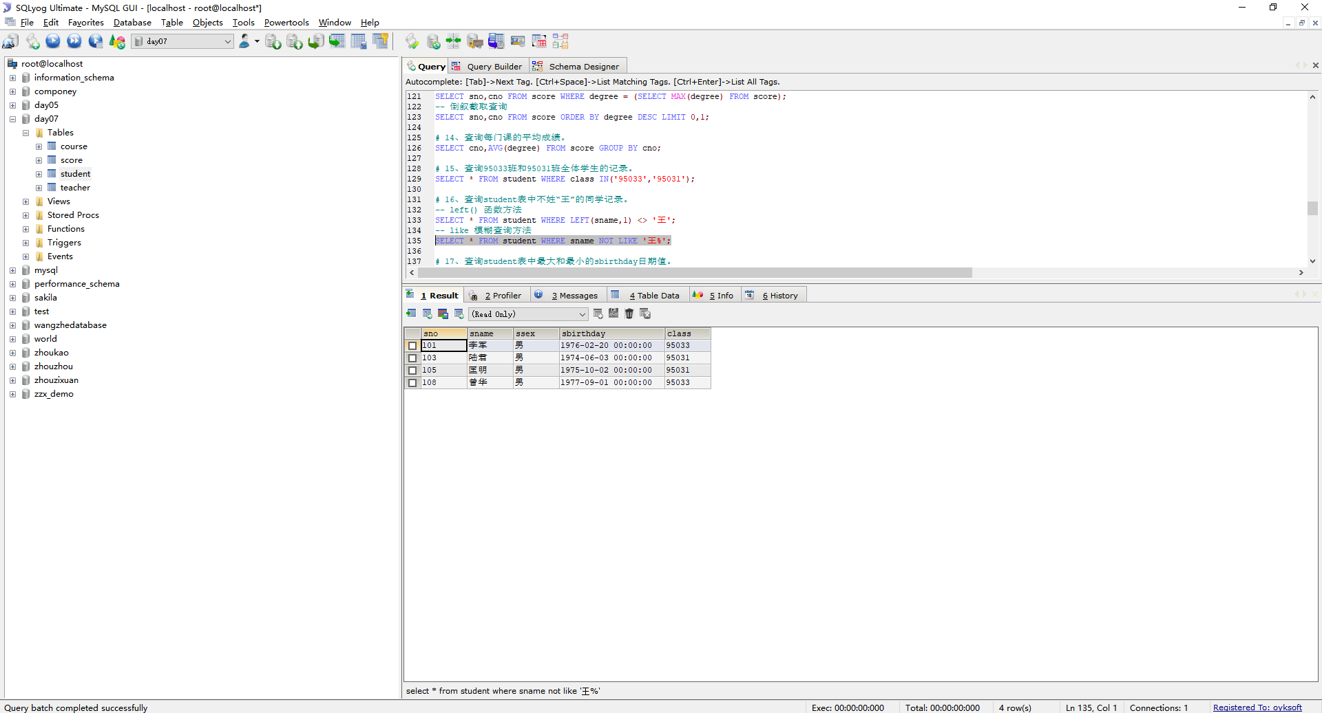

## 

## 查询student表中最大和最小的sbirthday日期值。

SELECT MIN(sbirthday),MAX(sbirthday) FROM student;

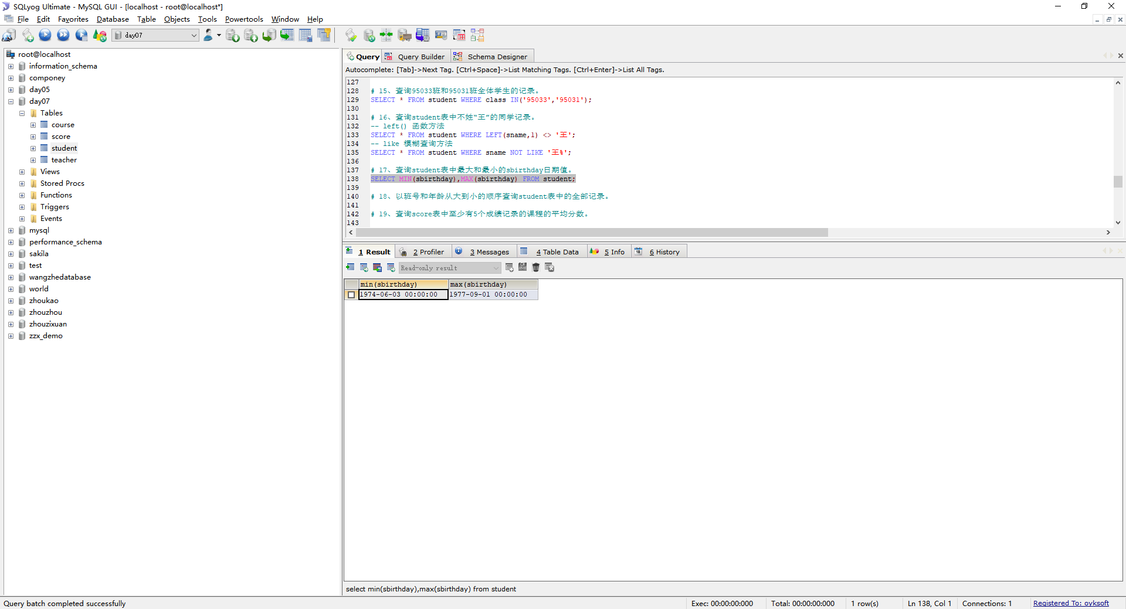

## 以班号和年龄从大到小的顺序查询student表中的全部记录。

个人感觉这个题目有问题 查询全部信息，只能用一个排序，没办法用多个排序，如果用多个排序，信息会乱掉

## 

## 19、查询score表中至少有5个成绩记录的课程的平均分数。

SELECT cno,AVG(degree) FROM score GROUP BY cno HAVING COUNT(*) >= 5;

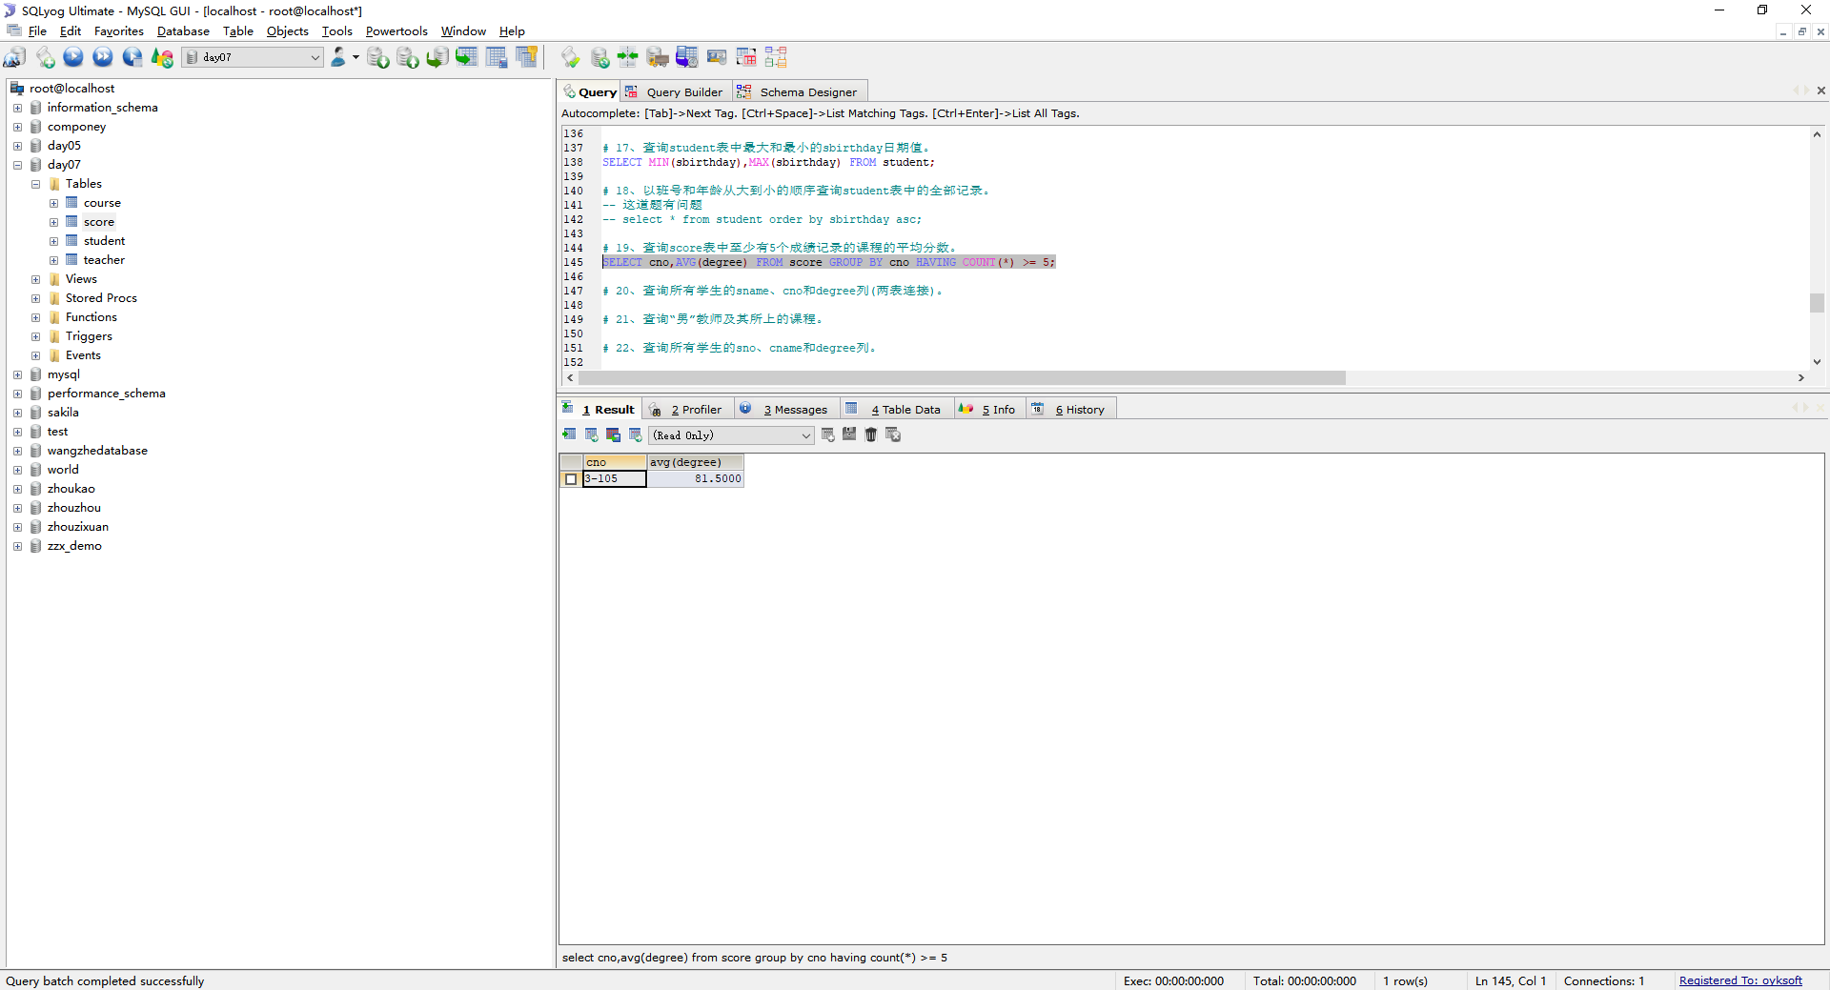

## 20、查询所有学生的sname、cno和degree列(两表连接)。

SELECT sname,cno,degree FROM student JOIN score ON student.sno = score.sno;

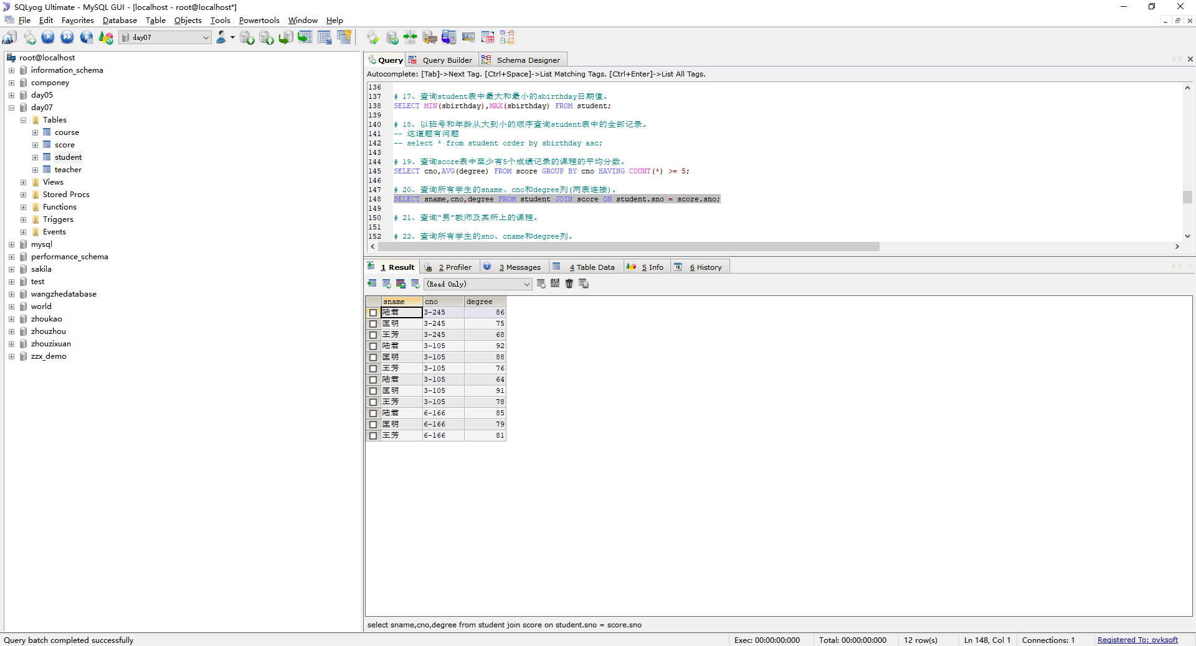

## 查询“男”教师及其所上的课程。

SELECT tname,cname FROM teacher JOIN course ON teacher.tno = course.tno WHERE tsex = '男';

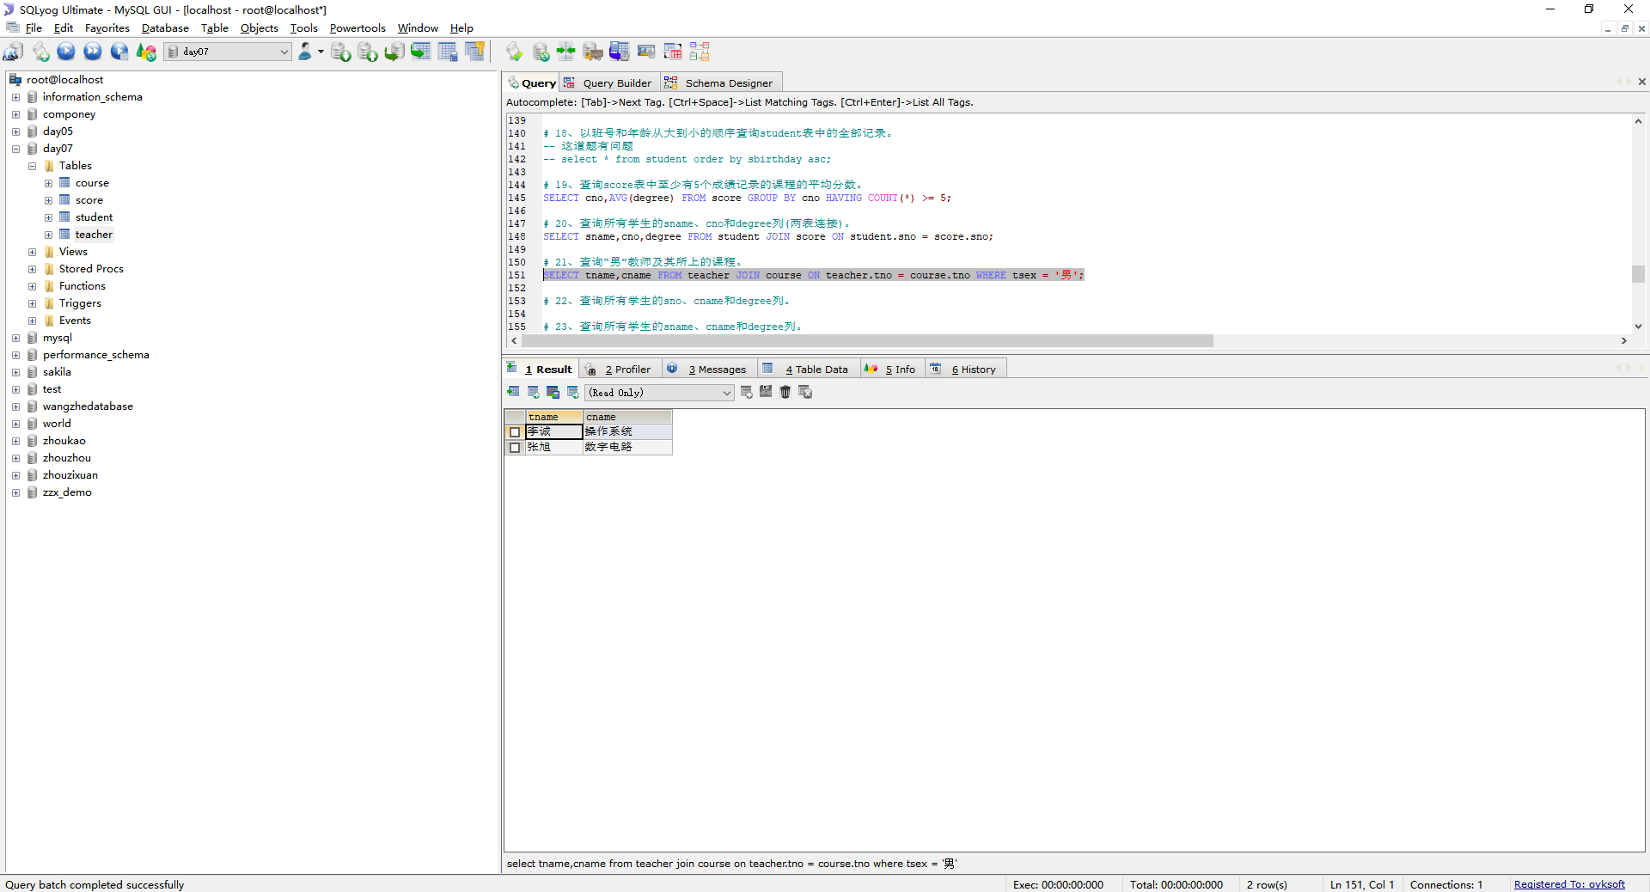

## 查询所有学生的sno、cname和degree列。

SELECT sname,cname,degree FROM student,score,course WHERE student.sno = score.sno AND score.cno = course.cno;

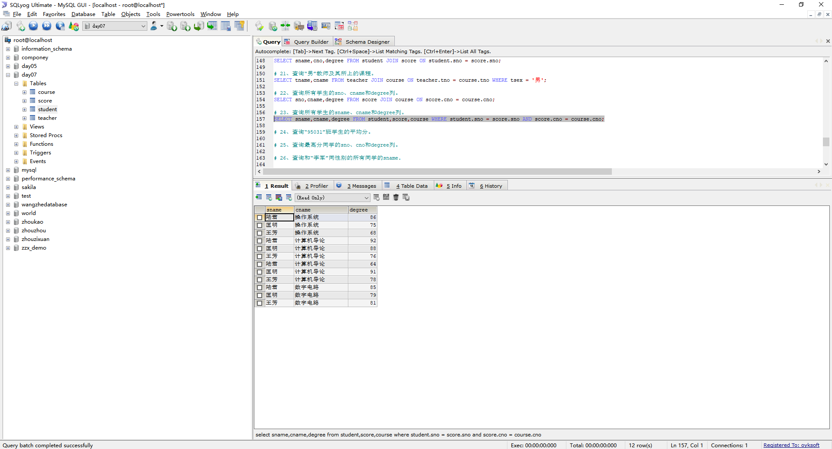

## 查询所有学生的sname、cname和degree列

SELECT sname,cname,degree FROM student,score,course WHERE student.sno = score.sno AND score.cno = course.cno;

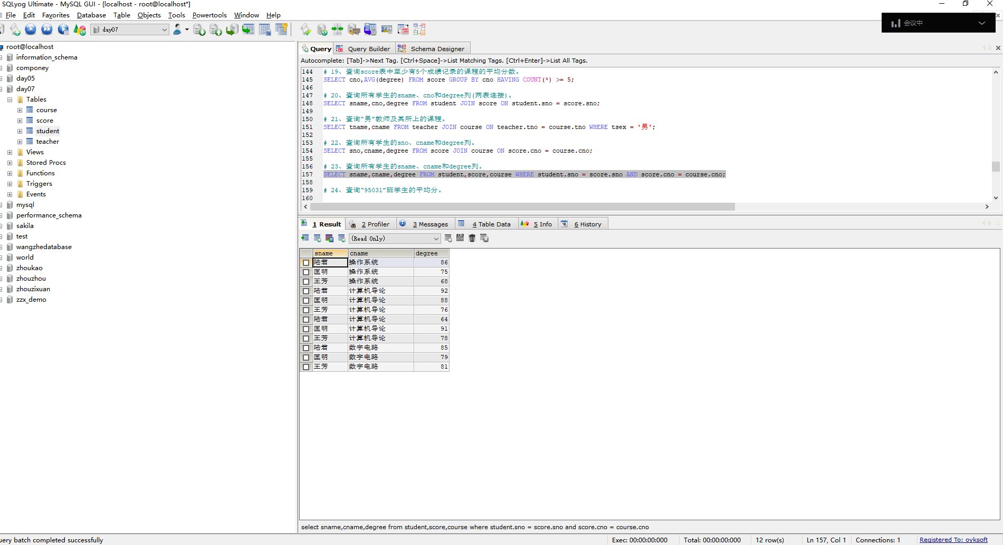

## 查询“95031”班学生的平均分。

SELECT AVG(degree) FROM score WHERE sno IN(SELECT sno FROM student WHERE class = 95031);

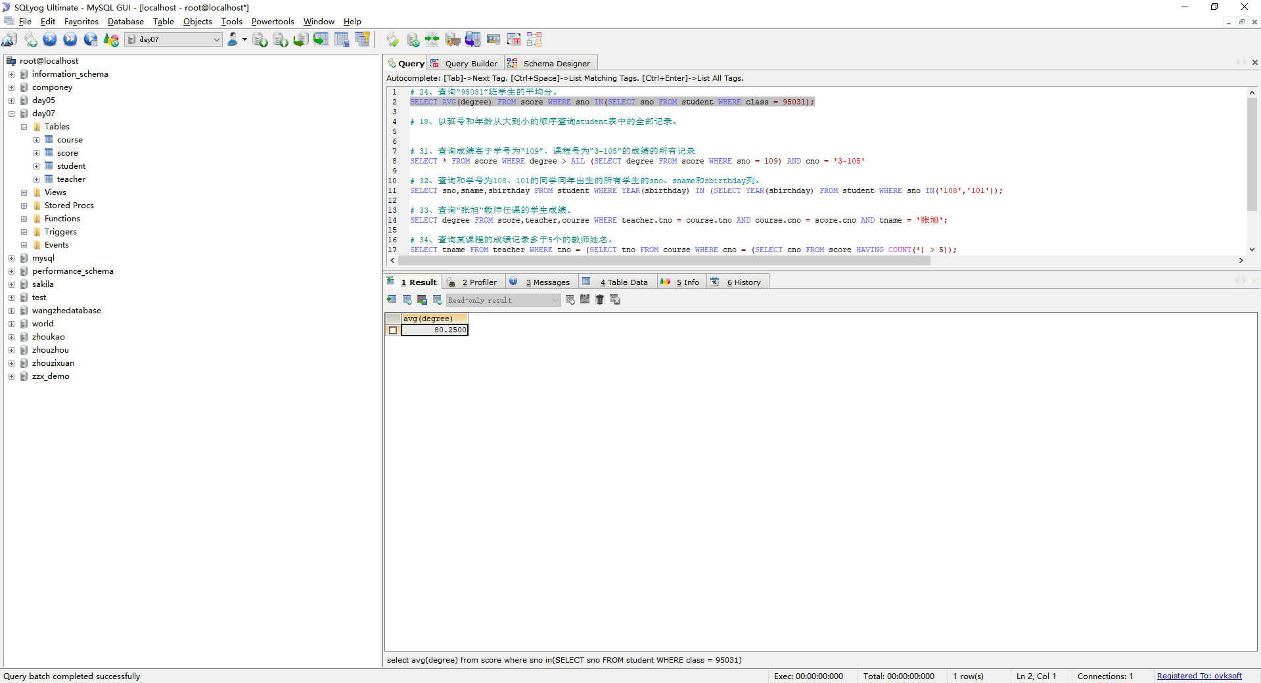

## 查询最高分同学的sno、cno和degree列。

SELECT sno,cno,degree FROM score WHERE degree = (SELECT MAX(degree) FROM score)

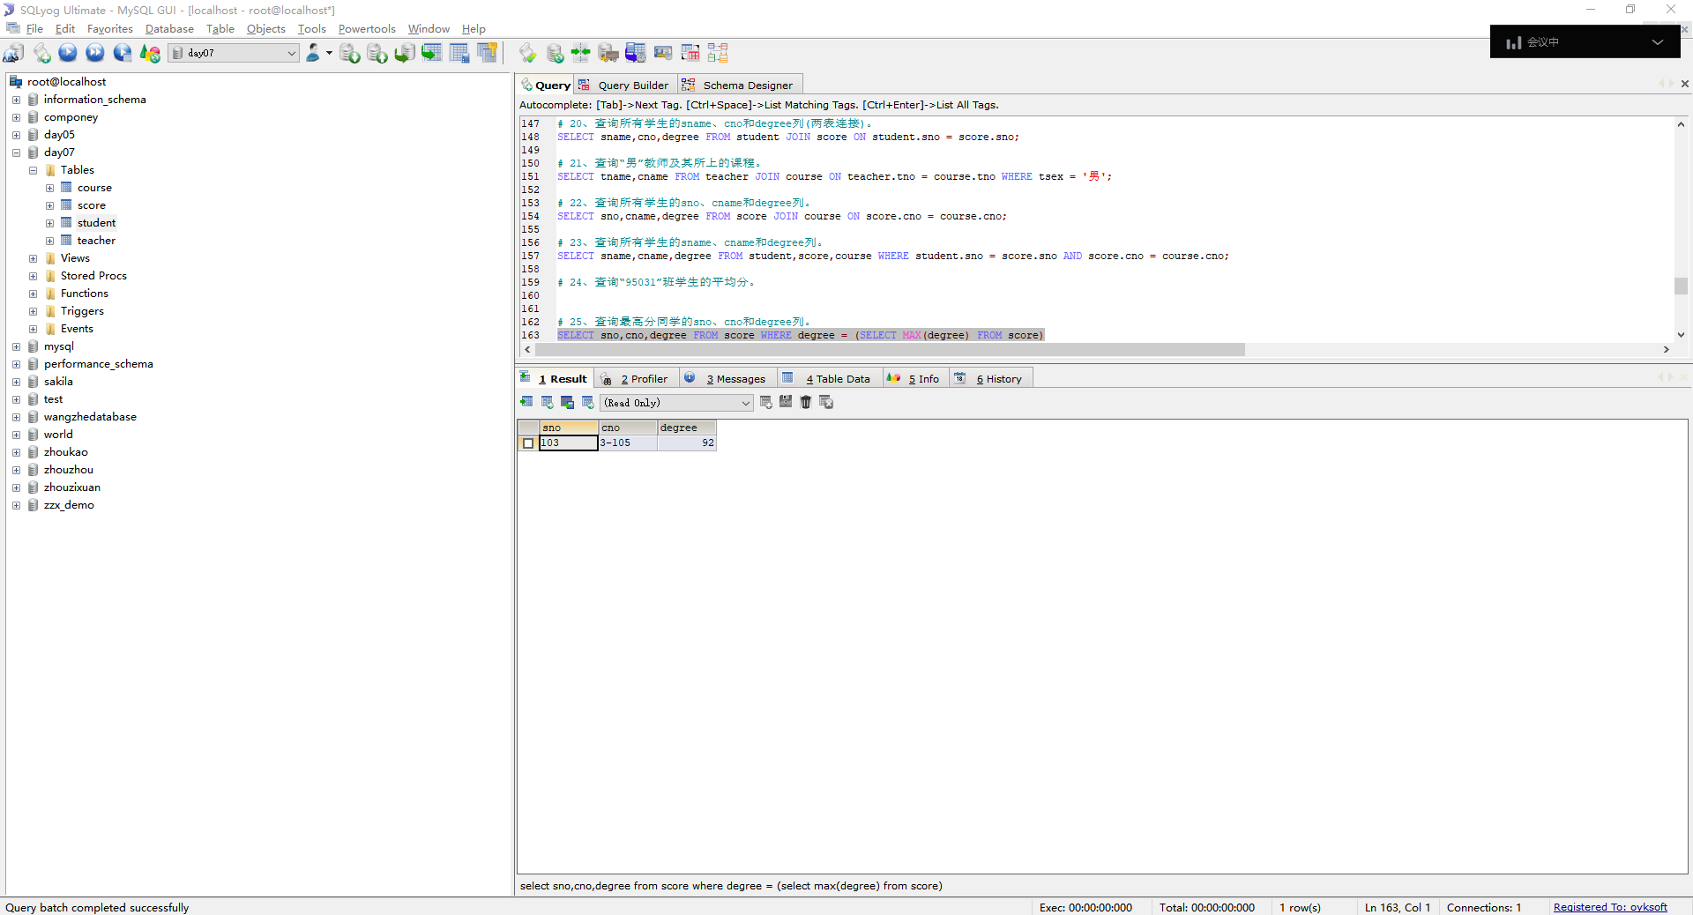

## 26、查询和“李军”同性别的所有同学的sname.

SELECT sname FROM student WHERE ssex = (SELECT ssex FROM student WHERE sname = '李军');

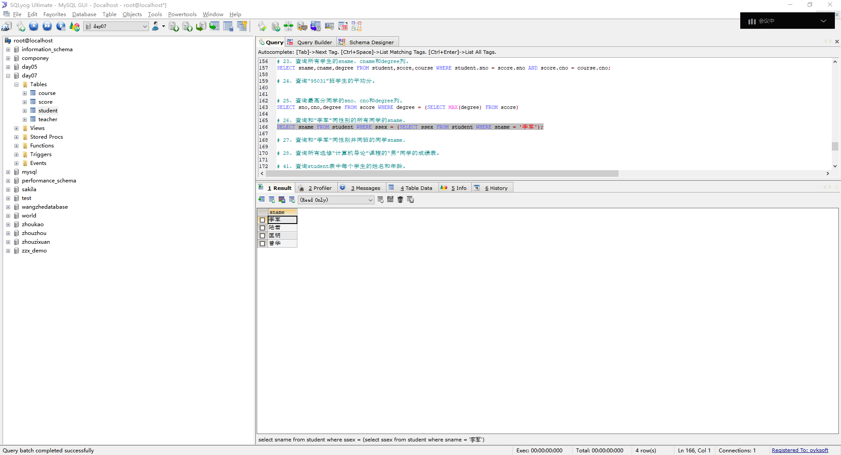

## 27、查询和“李军”同性别并同班的同学sname.

SELECT sname FROM student WHERE ssex = (SELECT ssex FROM student WHERE sname = '李军') AND class = (SELECT class FROM student WHERE sname = '李军');

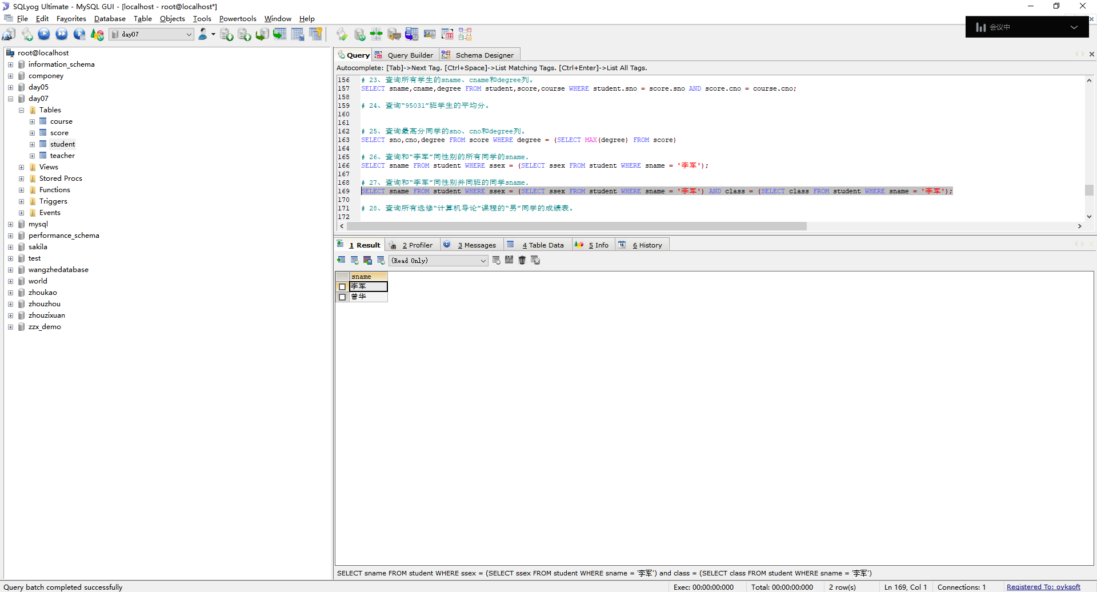

## 查询所有选修“计算机导论”课程的“男”同学的成绩表。

SELECT * FROM score WHERE sno IN (SELECT sno FROM student WHERE ssex = '男') AND cno = (SELECT cno FROM course WHERE cname = '计算机导论');

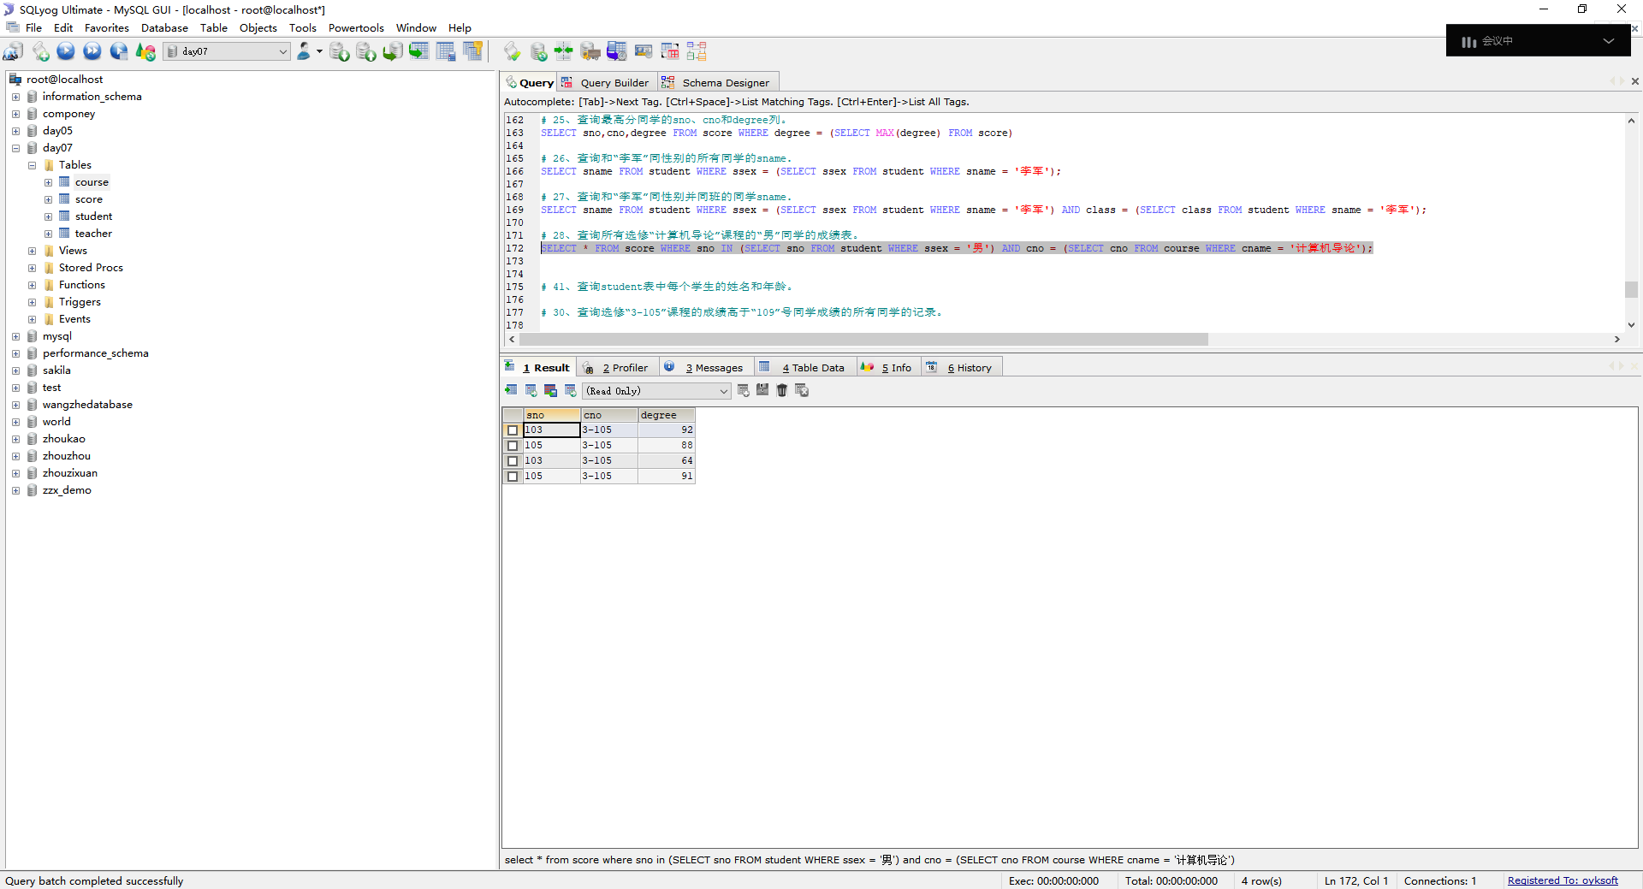

## 30、查询选修“3-105”课程的成绩高于“109”号同学成绩的所有同学的记录。

SELECT degree FROM score WHERE cno = '3-105' AND degree > ALL (SELECT degree FROM score WHERE sno = '109')

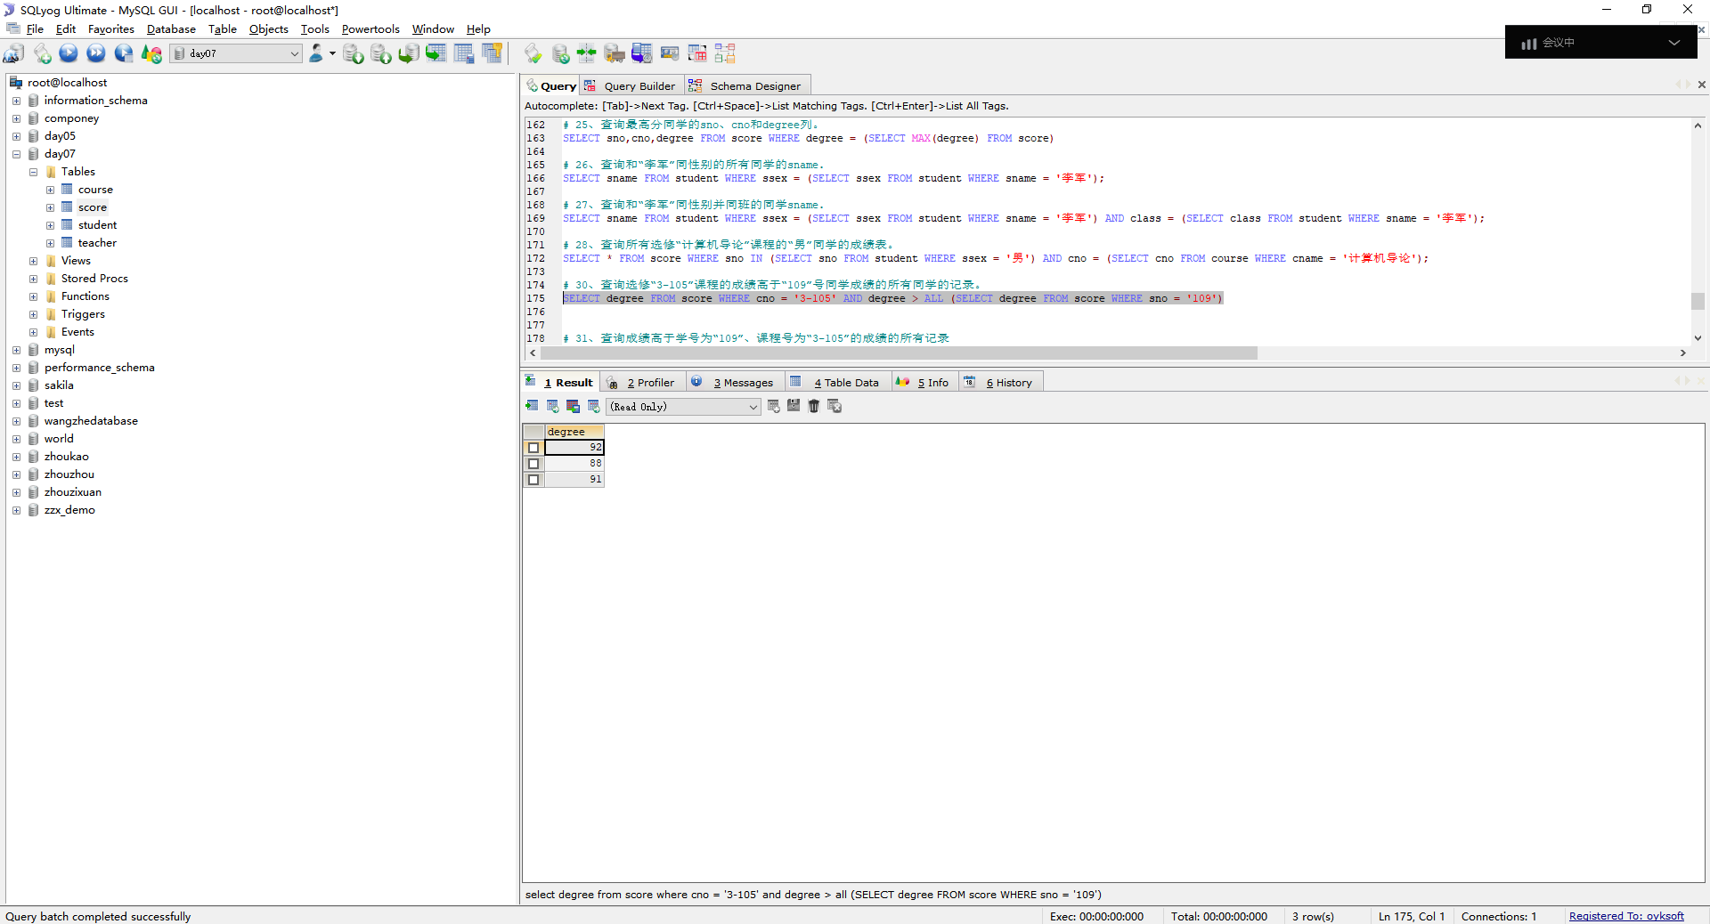

## 查询成绩高于学号为“109”、课程号为“3-105”的成绩的所有记录

select * from score where degree > all (SELECT degree FROM score WHERE sno = 109) and cno = '3-105'

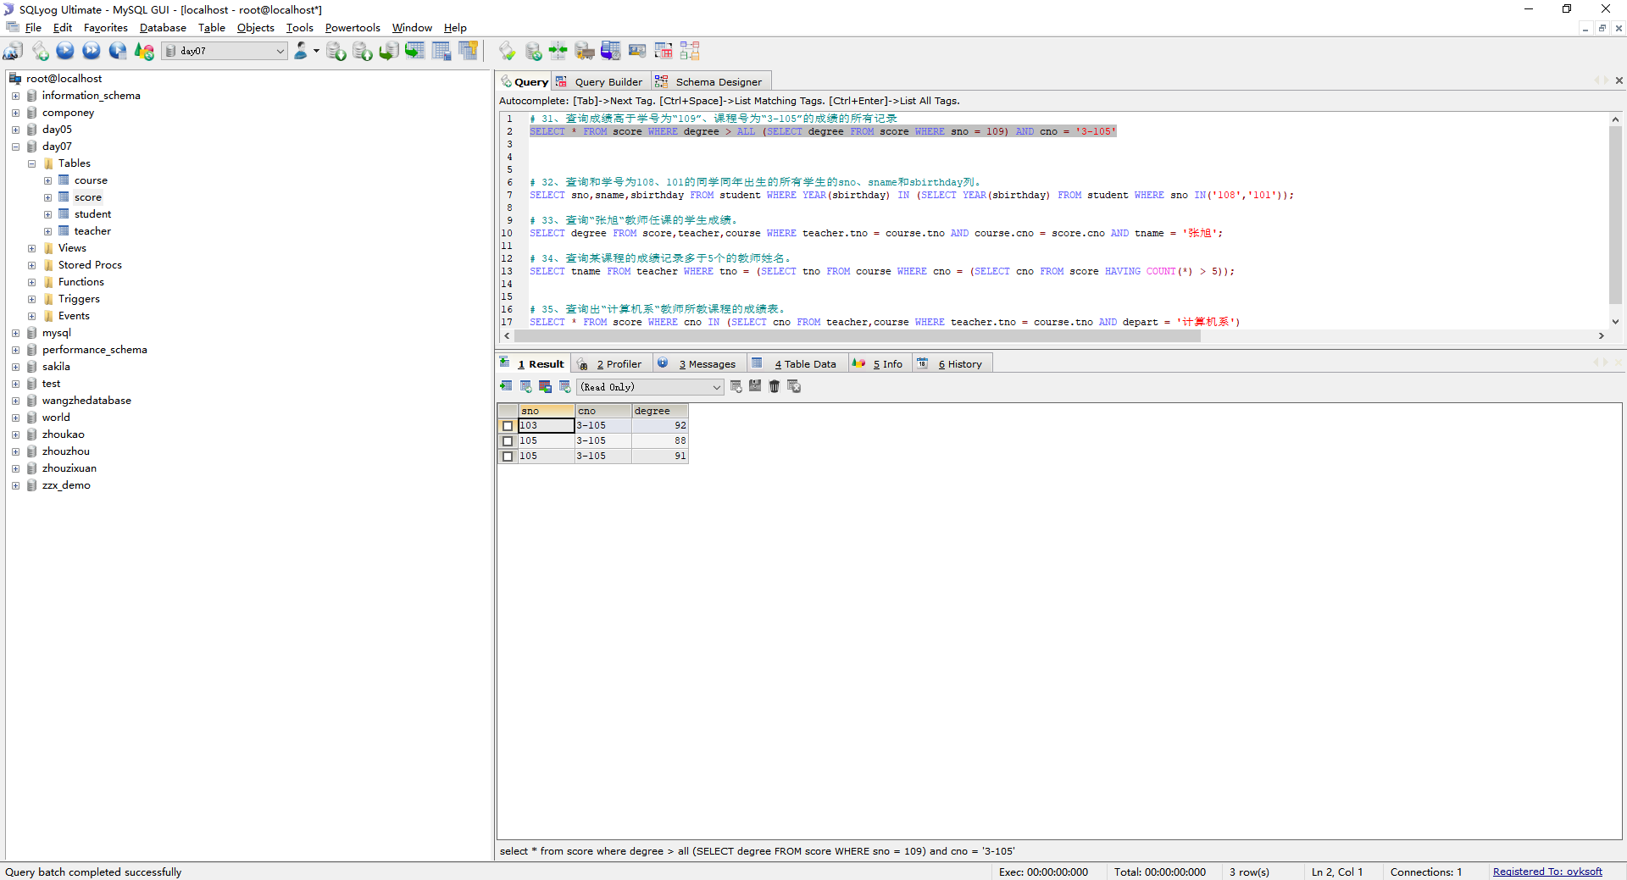

## 查询和学号为108、101的同学同年出生的所有学生的sno、sname和sbirthday列。

SELECT sno,sname,sbirthday FROM student WHERE YEAR(sbirthday) IN (SELECT YEAR(sbirthday) FROM student WHERE sno IN('108','101'));

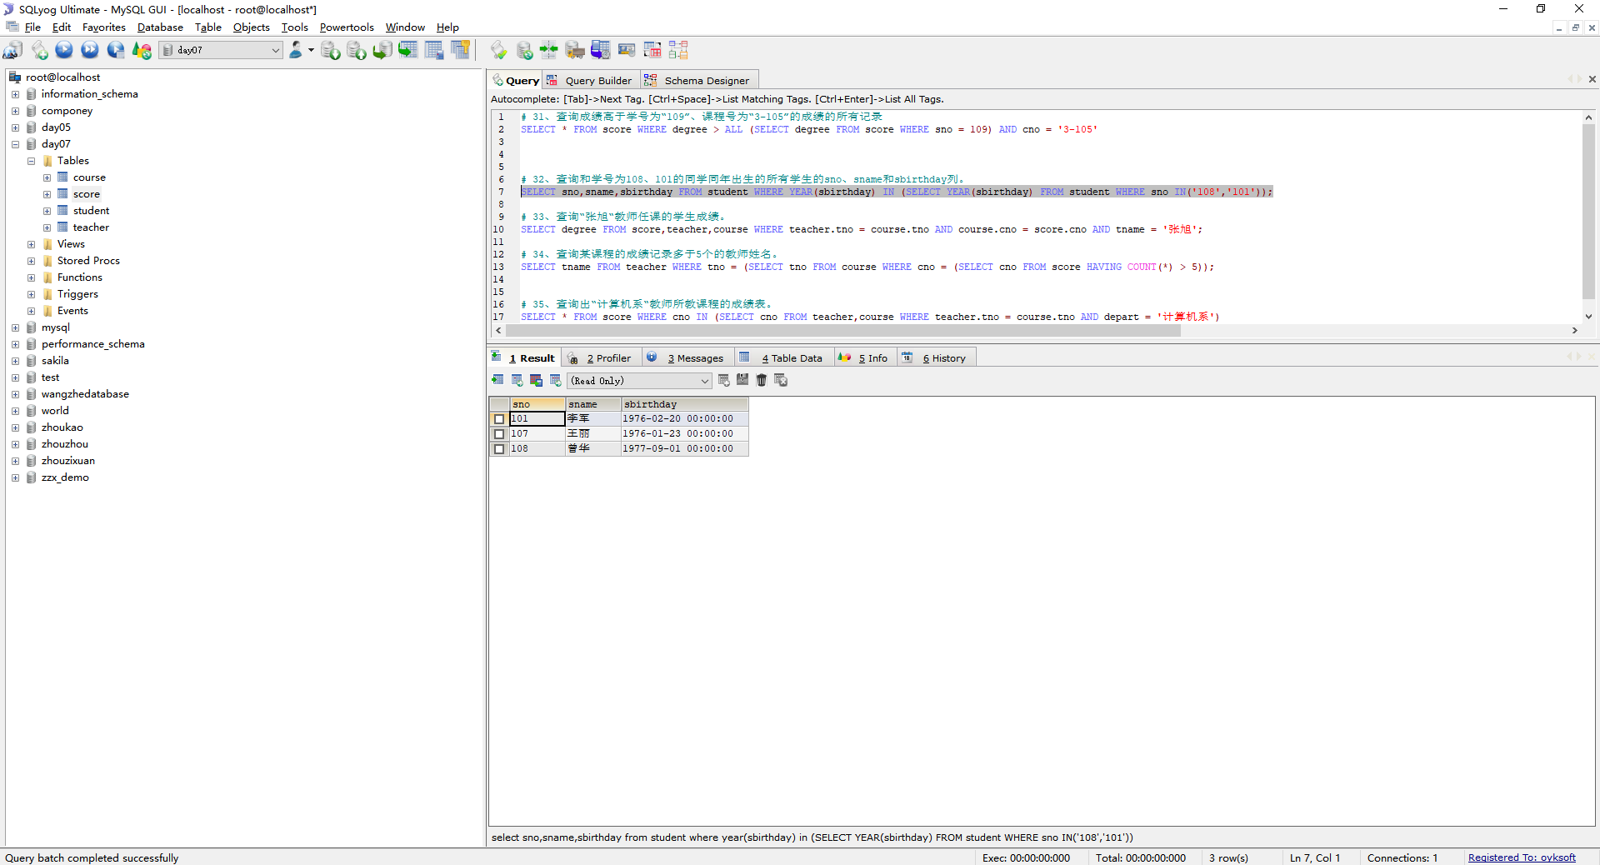

## 查询“张旭“教师任课的学生成绩。

SELECT degree FROM score,teacher,course WHERE teacher.tno = course.tno AND course.cno = score.cno AND tname = '张旭';

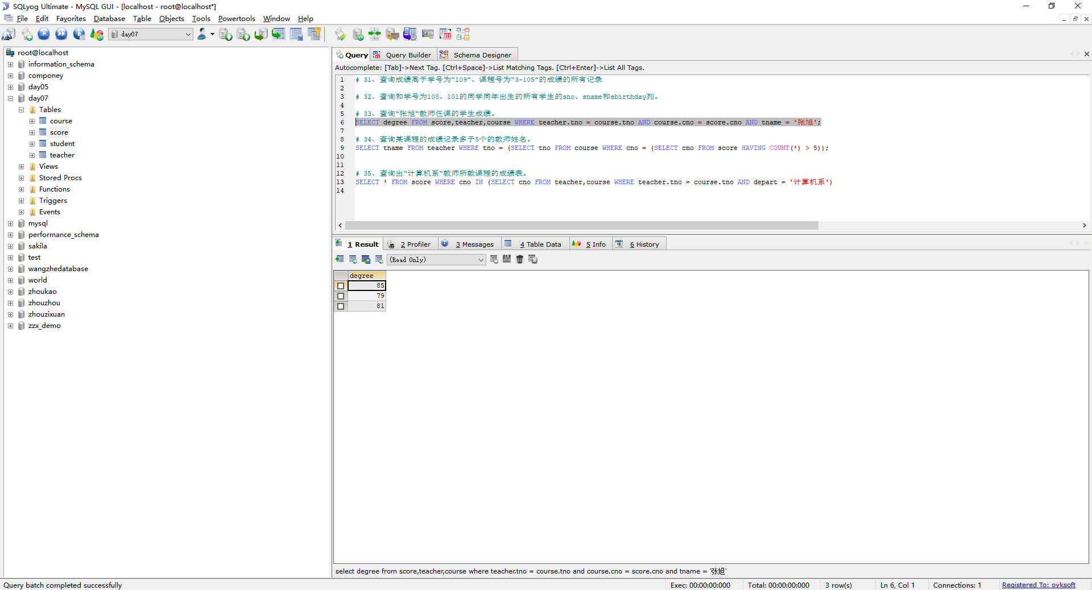

## 查询某课程的成绩记录多于5个的教师姓名。

select tname from teacher where tno = (SELECT tno FROM course WHERE cno = (SELECT cno FROM score HAVING COUNT(*) > 5));

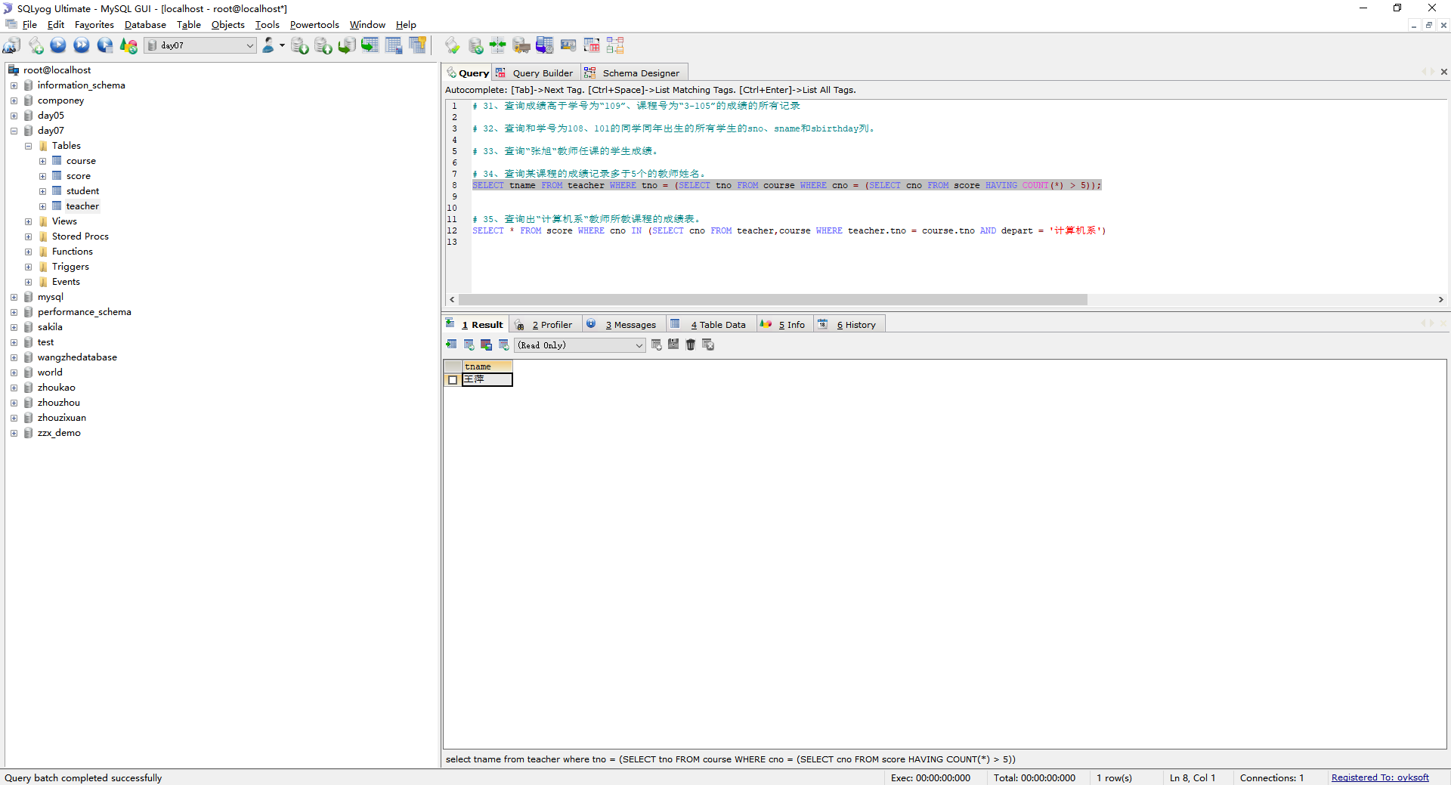

## 查询出“计算机系“教师所教课程的成绩表。

SELECT * FROM score WHERE cno IN (SELECT cno FROM teacher,course WHERE teacher.tno = course.tno AND depart = '计算机系')

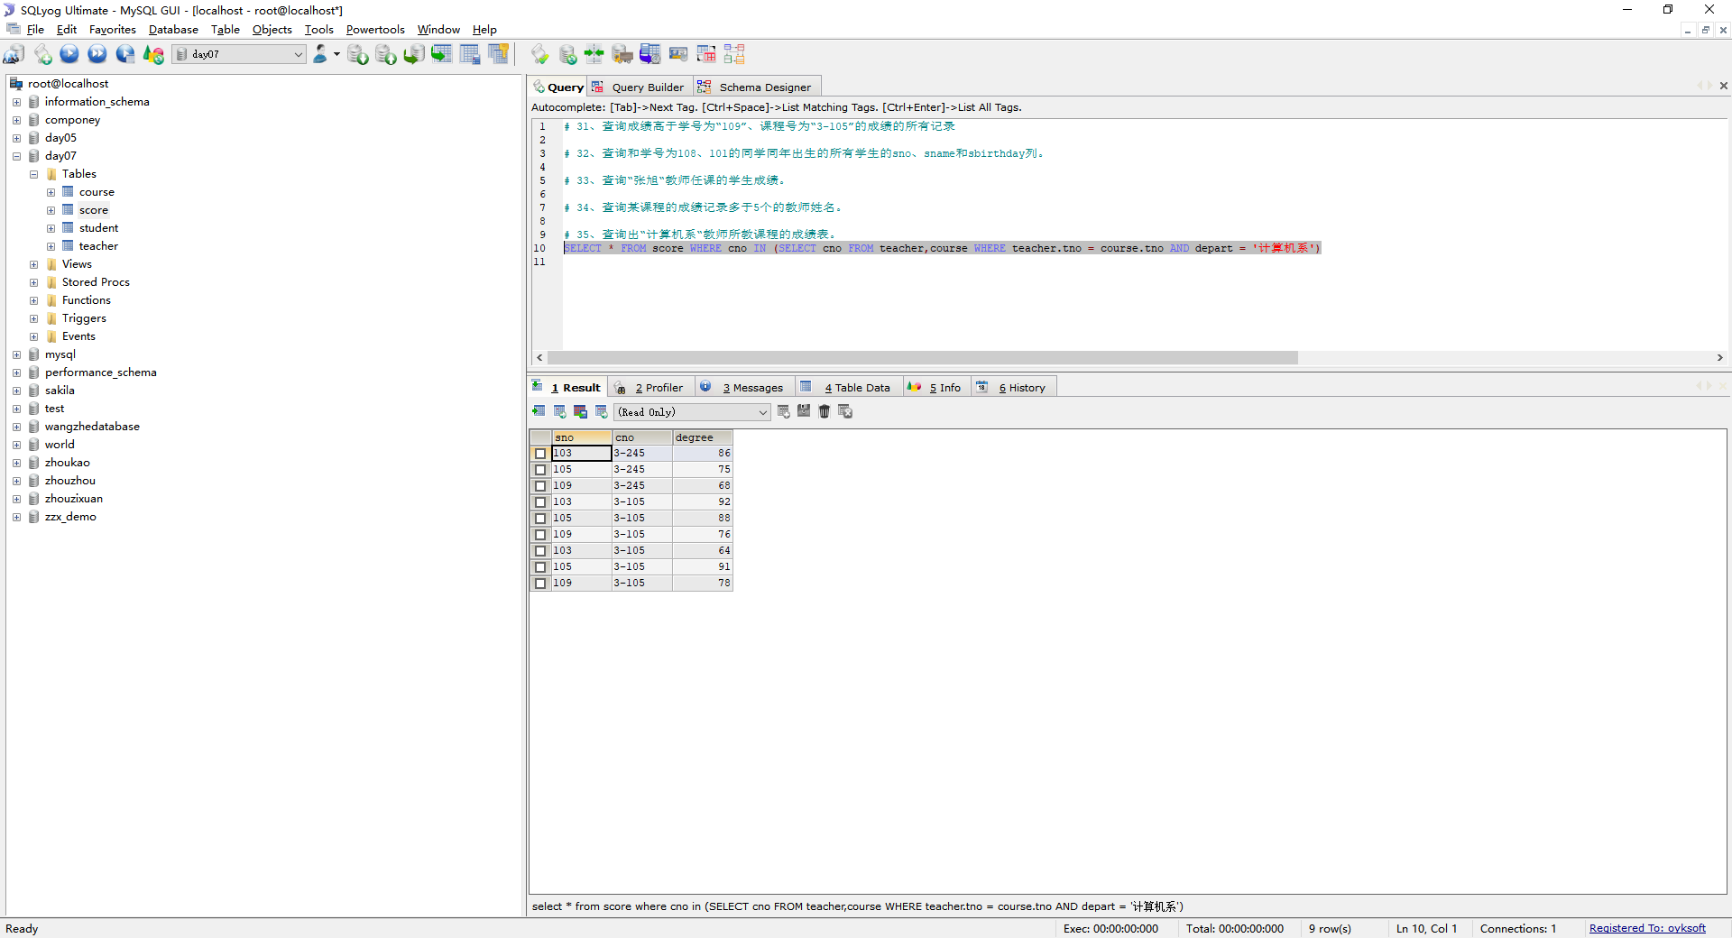

## 查询选修编号为“3-105“课程且成绩至少高于选修编号为“3-245”的同学的cno、sno和degree,并按degree从高到低次序排序

SELECT cno,sno,degree FROM score WHERE cno = '3-105' AND degree >= ALL (SELECT degree FROM score WHERE cno = '3-245') ORDER BY degree DESC;

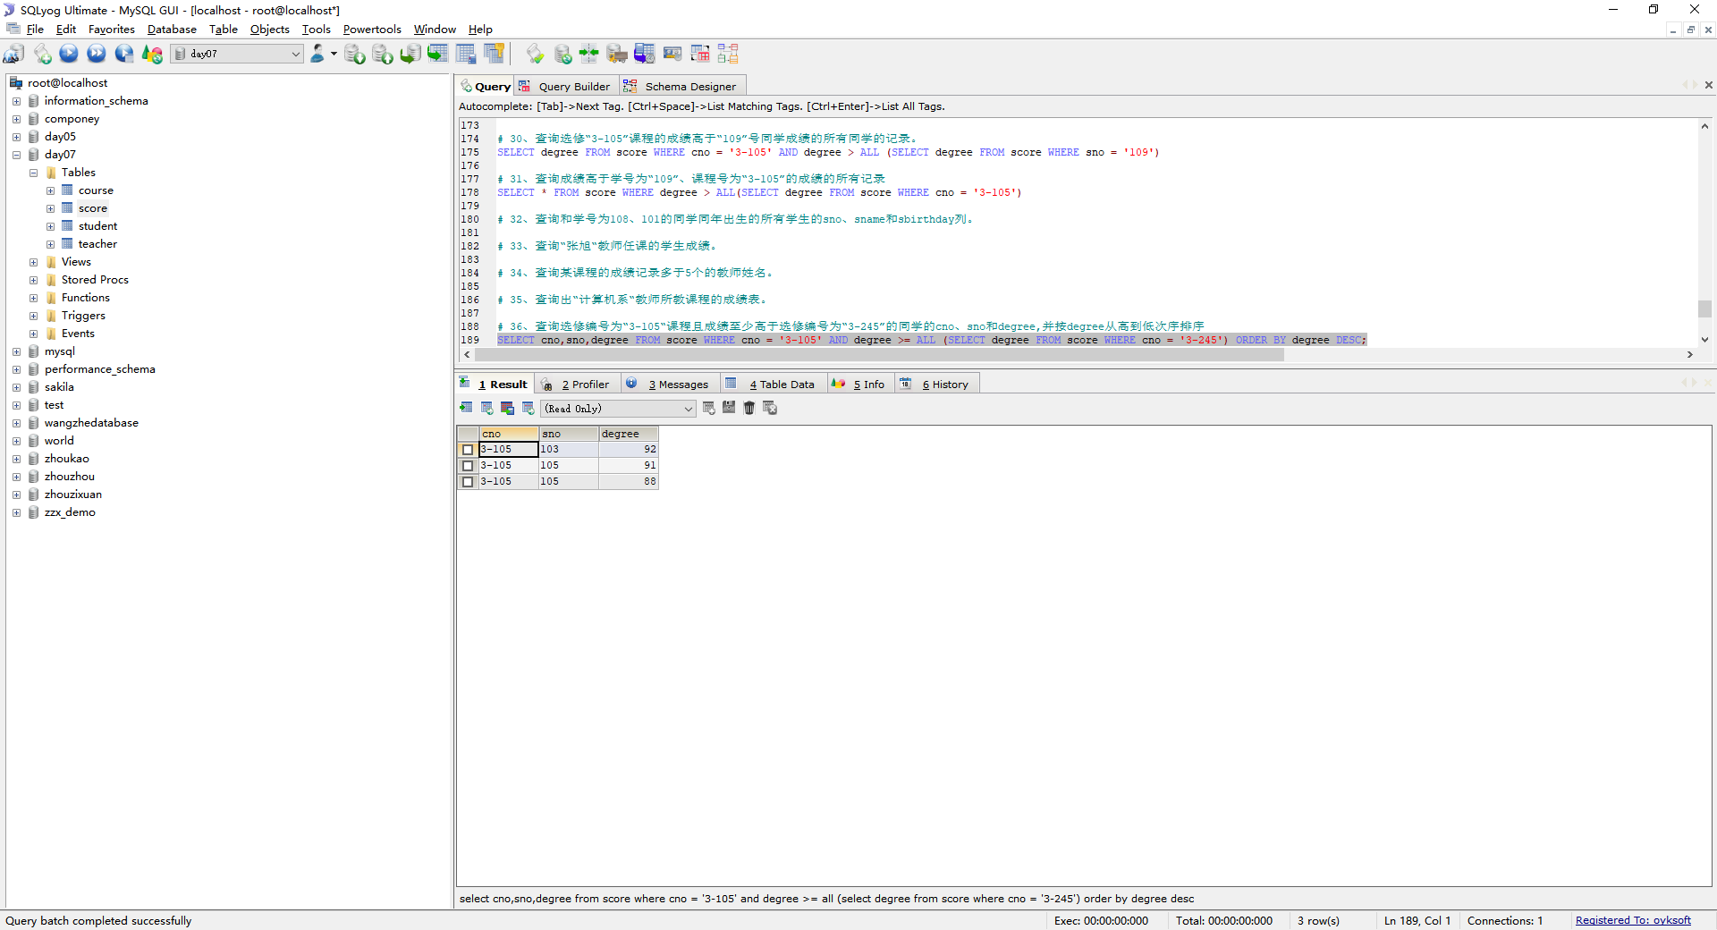

## 查询选修编号为“3-105”且成绩高于选修编号为“3-245”课程的同学的cno、sno和degree.

SELECT cno,sno,degree FROM score WHERE cno = '3-105' AND degree > ALL (SELECT degree FROM score WHERE cno = '3-245')

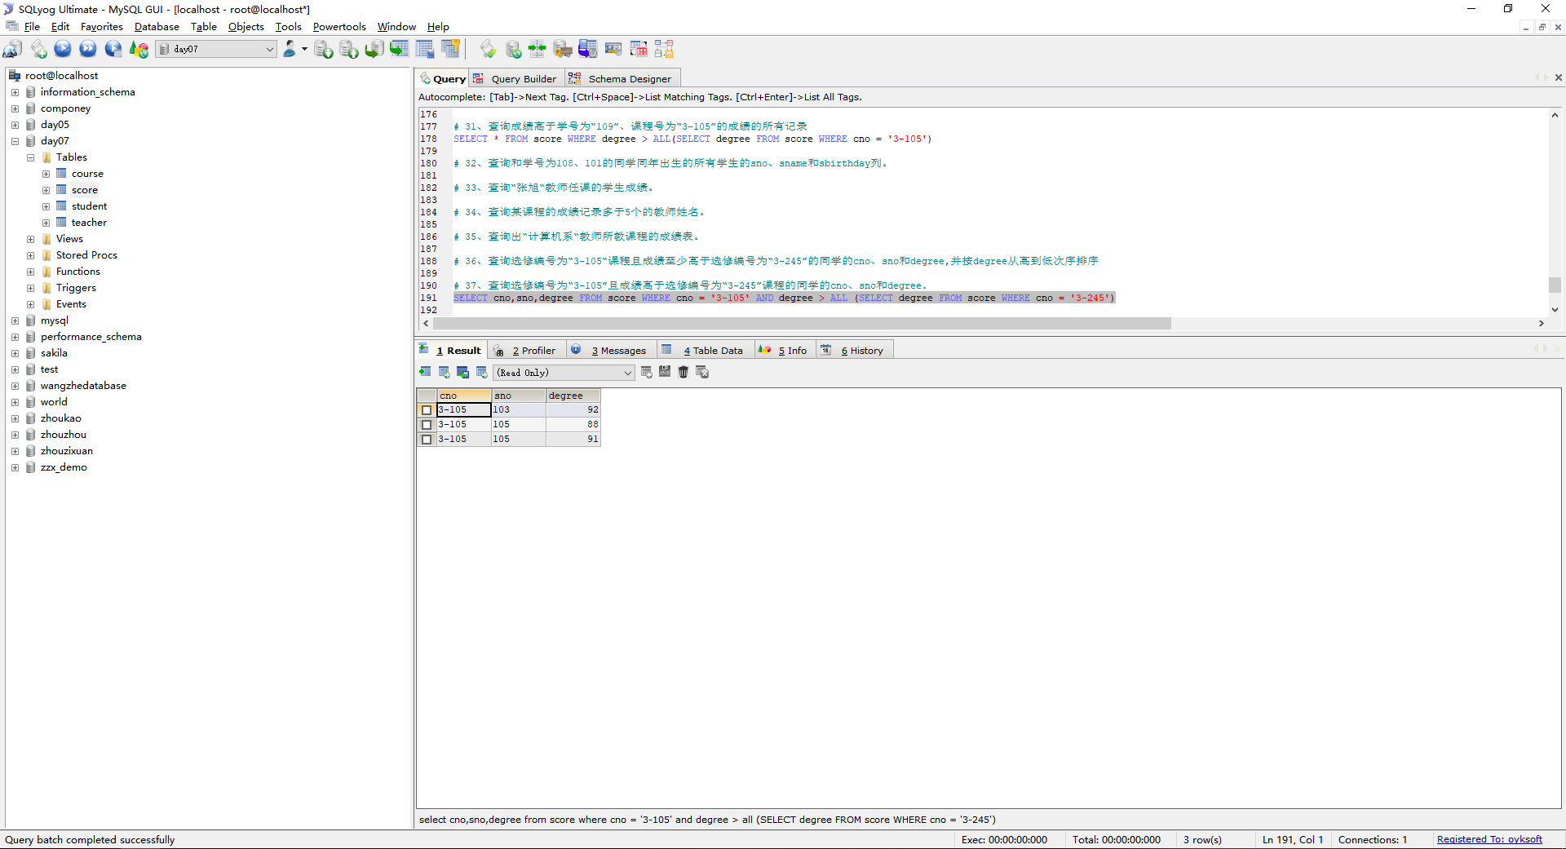

## 查询所有任课教师的tname和depart.

SELECT tname,depart FROM teacher WHERE tno IN(SELECT tno FROM course WHERE cno IN(SELECT DISTINCT cno FROM score ))

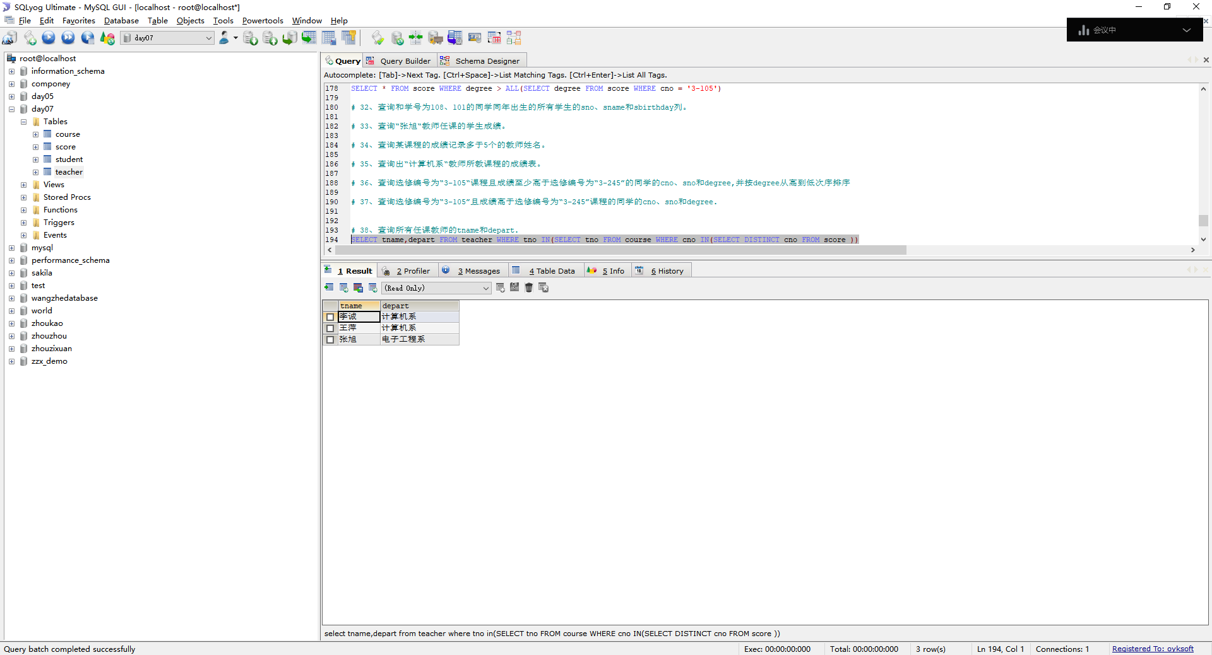

## 

## 查询所有未讲课的教师的tname和depart.

SELECT tname,depart FROM teacher WHERE tno = (SELECT tno FROM course WHERE cno = (SELECT cno FROM teacher,course WHERE teacher.tno = course.tno AND course.cno NOT IN(SELECT cno FROM score)))

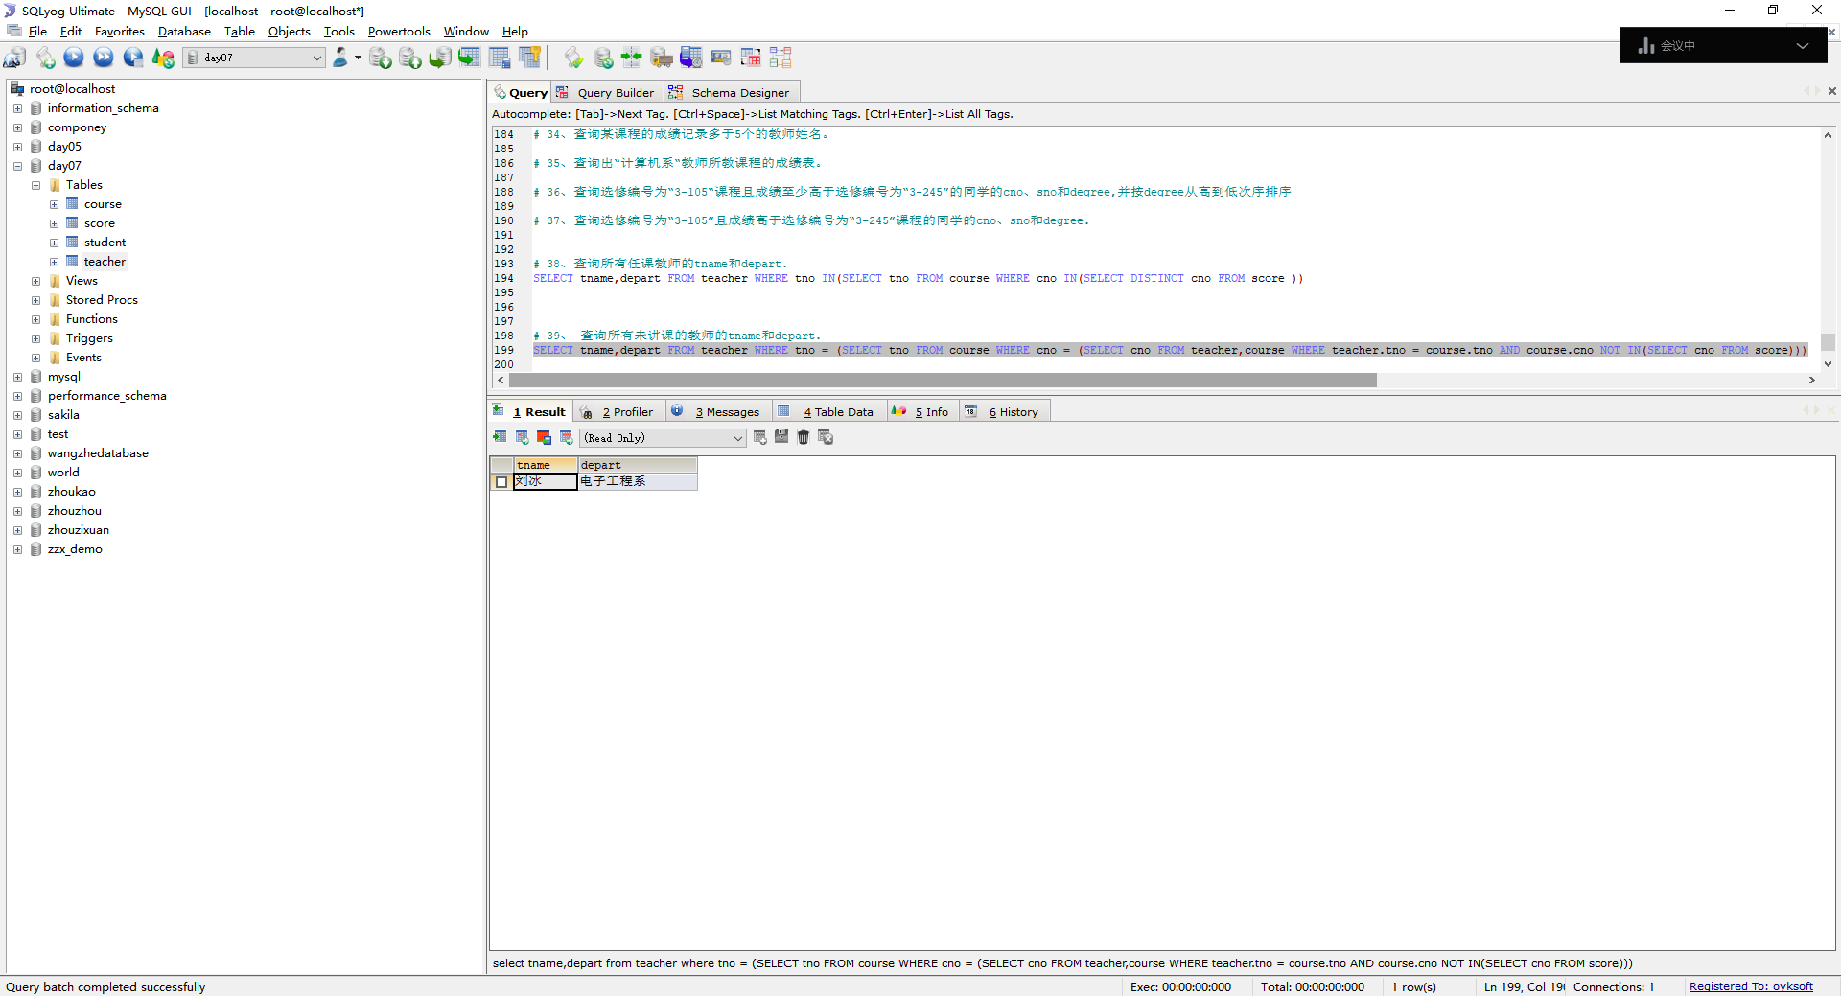

## 40、查询至少有2名男生的班号。

SELECT class FROM student WHERE ssex = '男' GROUP BY class HAVING COUNT(ssex) >= 2;

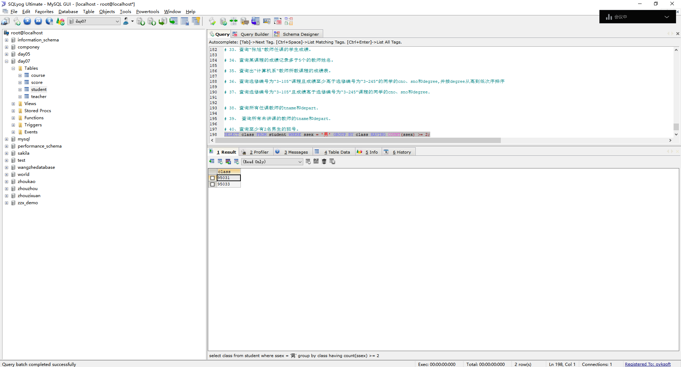

## 查询student表中每个学生的姓名和年龄。

SELECT sname AS 姓名,YEAR(NOW()) - YEAR(sbirthday) AS 年龄 FROM student;

